BOARD OF ADMINISTRATION

ACTIVITY REPORT
2014 – 2017

TABLE OF CONTENTS

1. General information
2. Private Management and Administration Plan of CONPET during the period 2014-2017
2.1. Objectives
2.2. Strategy
2.3. Stage of fulfillment of strategic objectives
2.4. Performance indicators according to Administration Plan 2014-2017. Fulfilment degree
3. Results of activity in Advisory Committees
4. The Board of Administration in relationship with shareholders
5. SWOT Analysis and Risk Management
6. Internal control management system component of integrated management system
7. Financial performance during 2014-2017
8. Investments – development during 2014-2017
9. Self-evaluation and conformity of activity of Board of Administration with requirements of Corporate Governance Code of BVB
10.Innovation and creativity
11. Strategic directions for ensuring ongoing performance

1. General information
Mandate period | Mandate Contract 06.12.2013 – 06.12.2017

Appointment act/mandate | - Decision of the Ordinary General Meeting of Shareholders no. 6/ 28.11.2013- director in Board of Administration  - Decision of Board of Administration no. 17/ 06.12.2013 – director general

Capacity in Board of Administration | Executive Director (member of Board and director general)

Advisory Committees from the Board of Administration to which he belongs | - Development Committee – according to Decision of Board no.17/06.12.2013 - president  - Committee for Relations with Regulatory Energy Authorities – according to Decision of Board no.17/06.12.2013- member  - Financial Committee and for Relationship with Investors – Decision of Board of Administration no. 17/ 06.12.2013 - member

Short biography | - I have over 27 years of professional experience.  - Apart from the capacity of member in the Board of Administration of CONPET, I have been director general since December 2012. Before, I held the position of executive director in Electrica SA (March 2010-December 2012) and director general /chairman of Board of Administration in CONPET S.A (February 2005 – March 2009). During the period 1989 – 2005, I had various positions in CONPET.  - I am holder of bachelor’s degree in sciences the at Oil and Gas University of Ploieşti and I graduated, in 2005, the Master in advanced technologies for environmental protection engineering.  - I graduated the Romanian-French MBA programme at the Academy of Economic Studies Bucharest carried out in collaboration with CNAM Paris (2006).

Documents that include assignments of the Board of Administration (BoA.) and Chairman of BoA | - Law no. 31/1990 for companies, republished, further amended and supplemented;  - GEO no. 109/2011 for corporate governance of public companies, further amended and supplemented (assignments regarding reporting);  - Law no. 297/2004 for capital market, further amended and supplemented;  - updated Articles of Incorporation of CONPET SA  - Administration Agreement signed;  - Regulations for Organization and Functioning (ROF) of BoA which contain information about: organization and functioning of BoA; assignments of BoA., method of work, liability of directors  - Corporate Governance Regulations of CONPET S.A., containing information about:  - the administration system and corporate governance structures  - Organization and assignments of General Meeting of Shareholders  - Structure of Board of Administration;  - Role and obligations of Board of Administration  - Appointment of members of Board of Administration;  - Remuneration of members of Board of Administration;  - Advisory Committees at Board of Administration level  - Director General  - Rights of shareholders  - Transparency, financial reporting, internal control and risks administration  - Conflict of interests and transactions with stakeholders  - Corporate information regime  - Social and environmental responsibility  - Internal Regulations regarding the organization and functioning of Advisory Committees created at the Board of Administration level, containing information about:  - Structure of Advisory Committees  - Composition of Advisory Committees  - Assignments of Advisory Committees  Advisory Committees created at Board of Administration level are responsible for the carrying out of analyses and elaboration of recommendations for Board of Administration in specific fields, by presenting to the Board monthly reports of their activity.  - Code of Ethics of CONPET S.A., by which the employees know and support the ethical values and values of the entity, observe and apply the ethics, integrity regulations, avoidance of conflicts of interests, prevention and reporting of fraud, corruption acts and reporting of irregularities in the Company.

Organization of the activity of the Board of Administration | The Company CONPET S.A is managed in unitary administration system.  The current Board of Administration is composed of 7 members and was selected and appointed according to the provisions of GEO no. 109/2011 for corporate governance of public companies, further amended and supplemented.  For the realization of an effective management process of the company we created an organizational entity at company level–Secretarial Office of BoA and General Meeting of Shareholders, entity which provides the secretariat of all the activities specific to the fulfillment of assignments of Board of Administration/General Meeting of Shareholders according to the provisions of GEO no. 109/2011, Law no. 297/2004 and Regulations of NSC no. 1/2006 and 6/2009.  The activity of BoA is carried out according to the legal regulations incidental to the activity of the Company and the applicable procedures.  For documentation of activities during the mandate period of the Board of Administration, the following documents are being chronologically archived, according to the legal provisions in force, by Secretarial Office of BoA and General Meeting of Shareholders:  -agenda for each of the BoA meetings  -reports of BoA meetings  -Decisions of BoA with the documents at the basis of these decisions (reports, information notices)  -Reports of Advisory Committees of BoA  -summoning lists of meetings OGMS and EGMS  - reports of meetings OGMS and EGMS  -Decisions of OGMS and EGMS with the documents on which the decisions were based  - other documents/letters received by BoA, General Meeting of Shareholders for information/  analysis/disposal of measures.  All the activity I have carried out with the other administrators was under full responsibility, professional deontology, integrity and transparency, efficiency and competitiveness, sustainability of activity and in agreement with the provisions of Articles of Incorporation of the company, the administration contract and good practices of corporate governance.

Policies and procedures regarding the organization and carrying out of activities  of the Board of Administration | The activity of the Board of Administration is carried out according to the Articles of Incorporation, Regulations for Organization and Functioning of Board of Administration, Internal Regulations for Organization and Functioning of Advisory Committees, applicable legal framework for the organization and carrying out of meetings of the Board and General Meeting of Shareholders and other policies and internal procedures that exist in the Company, which aim at the policy regarding sponsorship, risk management, archiving of documents.  While at regional European and national level we lay particular emphasis on the assurance of increase of transparency in business, elimination of corruption and implementation of the best practices of corporate governance in administration and management of majority state-owned companies, we analysed with the other directors the elaboration of a policy in this respect.

Transparency and communication
For the provision of correct and on time information to all the stakeholders on the activity of the Company, we supervised and monitored, coordinated in detail the communication and public information activity, so that it should be in line with the reporting requirements that CONPET SA falls under, as company listed on the Bucharest Stock Exchange and unique operator via pipelines of the crude oil, rich gas and liquid ethane.
The directions pursued with priority in this respect aim at issues such as:
- permanent alignment of the webpage of the company to transparency requirements and dissemination of information, imposed by the good practices of corporate governance;
- realization of public communications and financial reports compliant with the provisions of normative acts incidental to activity;
- provision of correct, complete and on time information and equal and non-discriminatory treatment in provision of information to all shareholders of CONPET S.A;
- provision of a state-of-the-art logistic support for the organization and carrying out of meetings of Board of Administration and General Meeting of Shareholders;
- dissemination of decisions of the Board of Administration according to the process procedures established;
- publication according to the legal provisions of convening lists and decisions of the General Meeting of Shareholders and materials for meetings of General Meeting of Shareholders (GMS) on the website of the company;
- maintenance of a permanent communication with top management of the company;
- improvement of internal and external relations system of the company.

The activity of Communication and Public Relations Department carried out during 2014 - 2017 had the purpose, on one hand, to increase the visibility of CONPET and the long-term development of new direct and constant contacts with the business partners, the customers and suppliers, mass media representatives, opinion poll trainers and other groups of interest, and on the other hand, the improvement of communication within the company.
The main objective of the actions carried out was the creation of a positive image of the company on the capital market in Romania and abroad, for the purpose of extending the activity of CONPET at regional and European level, our reputation being decisive in this respect.

Improving the image of CONPET S.A.
The number of promotional materials related to the activity and projects of the company, published in central and local media, increased by 600% in 2016, compared to 2013. The materials disseminated at national/international and local level consisted of:
- press releases regarding activities/wide-range actions carried out in CONPET (jubilee year ”115 years of transport of crude oil via pipelines in Romania”, tactic exercises of intervention carried out in locations which belong to CONPET - C4 Feteşti, Călăreţi plant, overcrossing of Prahova River - Stejaru, visits of personalities from the national and international business environment);
- interviews of the director general published in specialized magazines - Energynomics, Petroleum Industry Review, Energia, Bursa, Jurnalul de Afaceri –translated into English and broadcast to embassies, international business centres and international conferences;
- specializaed articles regarding the activity and major projects carried out by the company (yearbook ”Excelence for the future”, „Energynomics” magazine, „Argus” magazine);
- models/advertising spots disseminated to national and local televisions, local and central printed and online press.
In 2016 there were over 400 references of CONPET in the central and local media of which 99% positive and neutral.

Fig. 1 Evolution of press materials made during 2013-2016

The target represented by establishment of direct and constant contacts with the mass media representatives at central and local level, for increasing the visibility of CONPET in the internal and international business environment was reached.

Increasing the representation degree of CONPET S.A. in internal and international events, with large potential of positive reputation of the company
During the period 2014 – 2016, CONPET delegates participated in almost 300 wide-scope national and international events for the Romanian and world energy market, with major impact on the image of CONPET – conferences, congresses, meetings with accredited embassadors in Romania.
The representatives of top management of CONPET – director general and other management members had the opportunity, as speakers, to present the performances of the company and its future projects to a target specialized audience, decision-making factors and investors.

Fig. 2 Evolution of participation of CONPET delegates in internal and international events
Among the events carried out during the period 2014-2017, we emphasize the participation, here included exhibition stand, in two events emblematic for the international energy industry, as follows:
- The Regional Energy Forum from Central-Eastern European Region– FOREN, Constanţa, June 2016;
CONPET has benefited from the increased visibility of the event- 8 media partners, 18 representatives of TV media, radio, newspapers etc, dissemination of articles in specialized publications
(Petroleum Industry Review, Monitorul de Petrol și Gaze, Energynomics.ro magazine, The Diplomat magazine – Bucharest, online publication www. focus-energetic.ro, magazine Energyworld).

- The World Petroleum Congress, the most important profile event in the world, carried out in Istanbul, Turkey, in July 2017. The company represented Romania in the event, also in the Exhibition of the World Oil Congress, at the stand ROMANIA – CONPET. The Romanian delegation was led by the State Secretary in the Ministry of Energy, Mr. Robert TUDORACHE, and from CONPET, Mr. Liviu ILAŞI, Director General.

4
3
5
1
Romanian press agencies Local press of Prahova
Local press of Argeș Energy specialized magazines
Turkish press
Fig. 3 Media coverage for promotion of participation of CONPET at the World Oil Congress
The promotion of activity, projects and brand image responsible in internal and international business environment by the events where CONPET delegates participated have contributed to the increase of reputation and visibility of the company, especially on external level.

Increase of information degree of international audience
The volume of materials and reports regarding the activity of CONPET made in English and disseminated through the website of the company,www.conpet.ro , has significantly increased from 150 pages published in 2014 to almost 2 800 pages in 2016.
The sections “Investors Relations” and “Corporate Governance” represented 20% of total displays for pages on CONPET website, in the year 2016.
Implementation of a coherent social responsibility policy
At CONPET level coherent, efficient and dynamic social responsibility policies were implemented and meet the requirements and social needs of the local communities.
The company has supported the carrying out of over 100 social responsibility projects in the fields of education, medical field, sports, cultural – artistic field, etc.
Also, the number of volunteering actions substantially increased in 2016, compared to 2014. In the mentioned period, ten volunteering actions were carried out for the local community.
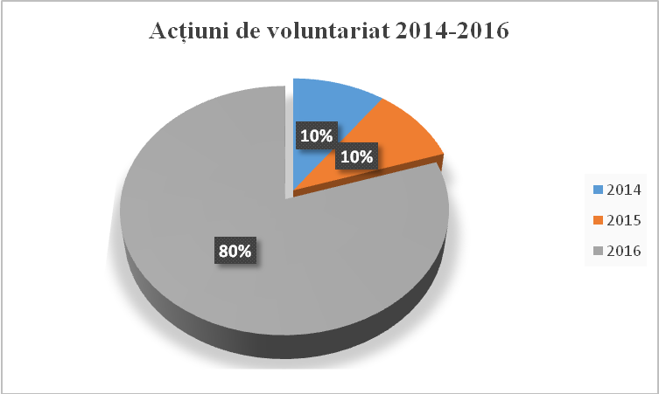
Volunteering actions 2014-2016

Fig.4 Weight of volunteering actions during 2014-2016

The intensification of activities in social responsibility field, including volunteering, but also the diversification of projects that CONPET has sustained have contributed to the increase of visibility of the company and consolidation of CONPET brand image.
Continuous improvement of internal communication inside CONPET
The activities carried out in the field of internal communication had in view the large dispersion of employees of the company in the territory, because the activity was carried out in working sites located in 24 counties of Romania. Thus, we emphasize the following actions:
- promotional films and powerpoint presentations were made and permanently broadcasted on the display from the headquarters of the company, where there is the heavy traffic knot with maximum visibility and on the occasion of various events organized in CONPET (festive events, meetings, works);
- since 2016, every week have been issued materials with recent news on the activity of the company and other information of interest for employees communicated internally by intranet;
- since 2016 informative materials (communications) were made and broadcasted by internal network (e-mail) regarding the special events in the life of the company (visits of personalities from business, cultural, academic environment, book presentations, etc);
- the newspaper Informația CONPET was regularly elaborated with internal broadcasting (at all points of work throughout the country), but also external broadcasting – at the level of central and local administration, including embassies in Romania.
- training programmes were organized for the staff with responsibilities of communication and representation of the company at different levels, and varied themes were tackled.
The activities carried out during the period 2014-2017, the approach of new directions of actions both in the field of external promotion of the company and in internal communication had the visible result of increasing the interest of specialized audience and mass media in the activity of CONPET, consolidation of company image and increasing the degree of information of employees.

Organization chart of the Board of Aministration

Chairman of Board
DAN WEILER
Non-executive Administrator
ROXANA-ELENA GHEORGHE
Non-executive Administrator
RĂZVAN-ȘTEFAN LEFTER

Non-executive Administrator
CRISTIANA CHIRIAC
Non-executive Administrator
DARIUS-DUMITRU MEȘCA
Non-executive Administrator
RADU BUGICĂ
Executive Administrator Director General
LIVIU ILAȘI

Surname and first names | Capacity in Board | Legal virtue based on which he/she was appointed | Duration of mandate
WEILER DAN | Non-executive Administrator  Chairman of BoA | Decision of OGMS no.6/28.11.2013- administrator  Decision of Board no.6/28.11.2013–temporary chairman  Decision of the Board no.1/21.01.2014– chairman | 4 years
ILAȘI LIVIU | Executive Administrator  Director General | Decision of OGMS no.6/29.11.2013 - administrator  Decision of Board no. 17/ 06.12.2013 – director general | 4 years
BUGICĂ RADU | Non-executive Administrator | Decision of OGMS no.6/29.11.2013 - administrator | 4 years
GHEORGHE ROXANA-ELENA | Non-executive Administrator | Decision of OGMS no.6/29.11.2013 - administrator | 4 years
CHIRIAC CRISTIANA | Non-executive Administrator | Decision of OGMS no.6/29.11.2013 - administrator | 4 years
MEȘCA DARIUS-DUMITRU | Non-executive Administrator | Decision of OGMS no.6/29.11.2013 - administrator | 4 years
LEFTER RĂZVAN ȘTEFAN | Non-executive Administrator | Decision of Board no. 12/29.09.2015- temporary for the period 29.09.2015-17.12.2015  By Decision OGMS no.5/17.12.2015- administrator | 2 years and 2 months

Note:
Mr. Răzvan Ștefan Lefter continues the mandate of Mr. Dragoș Lucian Dinu, elected administrator by Decision OGMS no. 6/ 28.11.2013 and who gave up to the mandate of administrator (request which was noted by the Board by Administrator of the Board no. 12/ 29.09.2015). In the same meeting of the Board, Mr. Răzvan Ștefan Lefter was appointed temporary administrator, after he was appointed administrator by Decision OGMS no. 5/ 17.12.2015.

Composition of Advisory Committees

The composition of Advisory Committees created at Board of Administrator level, according to the provisions of Law no.31/1990 art.138^1 paragraph2, art.138^2 paragraph 2, art.140^2 para.(1), para. (2) of GEO no.109/2011 art.34, art.35 para. (2) and art. 55 para.(2) and para.(3) of Corporate Governance Code is as follows:

- NOMINATION AND REMUNERATION COMMITTEE
WEILER DAN | Chairman, non-executive administrator | Decision of the BoA no.16/28.11.2013
CHIRIAC CRISTIANA | non-executive administrator | Decision of the BoA no.16/28.11.2013
LEFTER RĂZVAN ȘTEFAN | non-executive administrator | Decision of the BoA no.13/16.10.2015

2. AUDIT COMMITTEE
GHEORGHE ROXANA-ELENA | President, non-executive administrator | Decision of the BoA no.16/28.11.2013
MEȘCA DARIUS-DUMITRU | non-executive administrator | Decision of the BoA no.16/28.11.2013
BUGICĂ RADU | non-executive administrator | Decision of the BoA no.16/28.11.2013

- FINANCIAL COMMITTEE FOR RELATION WITH INVESTORS
BUGICĂ RADU | President, non-executive administrator | Decision of the BoA no.17/06.12.2013
ILAȘI LIVIU | Executive administrator | Decision of the BoA no.17/06.12.2013
GHEORGHE ROXANA-ELENA | non-executive administrator | Decision of the BoA no.17/06.12.2013

- COMMITTEEFOR ELATIONS WITH REGULATORY ENERGY AUTHORITIES
CHIRIAC CRISTIANA | President, non-executive administrator | Decision of the BoA no.17/06.12.2013
WEILER DAN | non-executive administrator | Decision of the BoA no.17/06.12.2013
ILAȘI LIVIU | Executive administrator | Decision of the BoA no.17/06.12.2013
MEȘCA DARIUS-DUMITRU | Non-executive administrator | Decision of the BoA no.17/06.12.2013

5. DEVELOPMENT COMMITTEE
ILAȘI LIVIU | President, executive administrator | Decision of the BoA no.17/06.12.2013
WEILER DAN | Non-executive administrator | Decision of the BoA no.17/06.12.2013
GHEORGHE ROXANA-ELENA | Non-executive administrator | Decision of the BoA no.17/06.12.2013
MEȘCA DARIUS-DUMITRU | Non-executive administrator | Decision of the BoA no.17/06.12.2013
LEFTER RĂZVAN ȘTEFAN | Non-executive administrator | Decision of the BoA no.13/16.10.2015

The whole activity carried out by the Board of Administration CONPET S.A., since the takeover of mandate in November 2013, following the selection made according to the provisions of GEO no. 109/ 2011 and the election of administrators by Ordinary General Meeting of Shareholdersis reflected in Administrator ' Report, drawn up every semester/year and presented to the Ordinary General Meeting of Shareholders.
The quarterly, semestrial and annual reports are published on the website of the company http://www.conpet.ro/ , in section ”Investor Relations”, http://www.conpet.ro/investor-relations/reports/

2. Private management and Administration Plan of CONPET S.A. during 2014 – 2017
2.1. Mission, vision and values of the Company

CONPET has the mission to exploit the National Transport System of crude oil in conditions of safety and efficiency and assurance of free access at the available capacity of the system for all applicants, authorized legal persons, in equal, non-discriminatory and transparent conditions.
The vision of the Company is to keep the position of strategic player in oil industry as carrier of crude oil, gasoline, condensate and liquid ethan by pipelines and railroads in Romania and in perspective, to become an important regional player.
The values of the Company were identified and oriented to:
- learning and continuous perfection;
- respect for people and environment;
- opening and qualitative growth;
- flexibility and dynamism;
- communication and cooperation.

2.2. Strategic development objectives
In view of consolidating the position on the market and achieving the main purpose the Company, by Board of Administration, has established the following strategic objectives:

- development of new activities related to the basic activity;
- definition of Company as regional player;
- modern financial approach of business;
- decrease of operating expenses.

In this context, the key elements of CONPET strategy are:
- stimulation of revenues by development of new business areas by initiation of new income-generating activities (e.g. rental of storage facilities and development of atypical transport of crude oil and oil products);
- improvement of national transport network by implementation of the localization and leak detection system, modernization of cathodic protection system and monitoring, control and data collection system, renewal of pipeline network, carrying out of a rehabilitation programme and resizing of tank park, adjusted to the transported quantities;
- improvement of efficiency of activity by reduction of technological consumptions in the storage and transport processes, minimization of energy, fuel and lubricants consumptions, reduction of operating costs as a result of redefinition of necessity of pipline infrastructure;
- interconnection of National Transport System of crude oil with the Regional and European networks.

By adoption of GEO no. 109/2011 for corporate governance of public enterprises, the Government of Romania has undertaken the responsibility that for the future these companies are not influenced by politics and are run by professional managers selected in transparent way by recruitment companies recognized internationally and locally, agreed by a unitary process by all the partners involved (Government, IMF, EU).
In consideration that the efficiency and competitiveness of an economic operator decisively depend on the performance of its management, the correct implementation in the functioning of the company of good corporate governance mechanisms, based on GEO no. 109/2011, in CONPET S.A. the private management was implemented since November 2013.
CONPET S.A. is the unique operator of the National Transport System of Crude Oil via Pipelines, and signed with NAMR a system concession Agreement for a period of 30 years.
The Company provides the fulfilment, in conditions of efficiency, transparency, safety, non-discriminatory access and competitiveness of national strategy which aims at energy field, with observance of legislation and national and European standards of quality, performance, environment and sustainable development.
In this context, in the light of the need to ensure the energy security of the country, by development of strategic projects oriented for the use of transport capacities by existing pipelines, at the same time with maintenance at minimal level of the cost of transport activity of crude oil by pipelines, the Company has entered under private professional management in an important moment of its existence.
The Company CONPET S.A. has a unitary administration system being run by a Board of Administration composed of 7 members. Thus, the new administrators of the company were selected professionally and the new Board of Administration stook over the mandate regarding the administration of CONPET S.A., and proceeded immediately to the elaboration of Administration Plan of the company for the period of mandate 2014-2017, as set out by art. 30 paragraph (1) of GEO no. 109 /2011 for corporate governance of public enterprises, further amended and supplemented.
As the Administration Plan of CONPET S.A. during 2014-2017 represents an important instrument of strategic planning regarding the administration of the company, which is listed at the Bucharest Stock Exchange, we paid together with the other administrators maximum attention to the objectives envisaged for the clear establishment of the necessary stages for the operational efficiency of activity and managed that in its construction and implementation, the Administration Plan is governed by a responsible, professional and ethical attitude towards all stakeholders (shareholders, employees, partners, community, authorities and state institutions, media, etc.),
The Administration Plan of CONPET S.A. for the period 2014 - 2017 was approved by Decision of the Ordinary General Meeting of Shareholders no. 3 of 27.03.2014.
Given the importance for the country and Company of the missions undertaken, the private professional management of CONPET S.A. has committed to assure an efficient, transparent and state-of-the-art corporate governance by the valorisation with maximum efficiency of current and future opportunities, to allow the Company to achieve excellence in business, its transformation into a transport operator of crude oil by pipelines with international recognition in the field of energy, a leader on energy market in the region, contributing thus to the definition of Romania as an important energy corridor in the field of transport via pipelines to Europe.
The administration plan of the national transport operator of crude oil by pipelines drawn up for the period 2014-2017 confirms the strategic vision of directors regarding: the sustainable development directions of the company, optimization of economic financial and operational performances, increase in viability of the company in the national and international energy context under continuous change.
By valorising with maximum efficiency all the current and future opportunities by Administration Plan for the period 2014 - 2017, we thoroughly structured the strategic directions of action regarding the administration of resources, operational and management processes of the company for the realization with maximum efficiency of the performance objectives established and the transformation of CONPET S.A. into a company with international recognition in the field of transport of crude oil by pipelines.
Reconsidering the activity of CONPET S.A. depending on the evolution of European and national oil sector, the future objectives of European energy policy, the priorities of national energy strategy, the environmental changes in which the company carries out its activity, the objectives and administration directions of the company established for the period 2013-2017 were directed mainly toward the following fields:
- conformity with requirements of European and national regulations regarding transport of crude oil by pipelines;
- optimization and efficiency of operational process;
- sustainable development of the company.
The administrators of CONPET S.A. considered that by the objectives set in the Administration Plan of the company for the period 2014-2017, objectives taken up and undertaken by the director general and executive management, in the Management Plan, the Company will achieve the goals regarding the efficiency of activity of the Company and its redefinition according to requirements of modern performance standards and competitiveness on regional, European and international level.
With an experience of over a century in the field of transport of crude oil via pipelines, strategic activity of national economy, CONPET S.A. is one of the great national companies in which the corporate governance model successfully works.
The results obtained during the period 2014 - 2017 are based on the measures and approaches of the BoA regarding the company management mainly by:
- Re-design of organizational structure by a new modern and efficient organization chart according to requirements of activity regarding the safety and security of exploitation of the National Transport System of crude oil by pipelines, its competitiveness and modernization;
- efficiency of institutional relations at national level (Parliament, Government, NAER, NAMR) and as applicable, at international level
- Efficiency and responsibilization of activities of Advisory Committees and increase in responsibility of the company staff
- Optimization of operational activity, investments and development, improvement of related activities to basic activity.

2.3. Stage of fulfilment of strategic objectives

I. DECREASE OF OPERATING COSTS – fulfilled strategic objective
Action | Steps/Monitoring | Fulfilment level / Stage
1. Redefinition of long-term necessity of transport infrastructure following the current situation of regional and local profile industry having as effect the reduction of operating costs | In the limits of current public information regarding the future perspective of activity of customers, we analysed and optimized the exploitation method of National Transport System of Crude oil by redefinition of pumping scenarios. | Fulfilled  Continuous nature
 | Every year we identify the surplus assets (sections of pipelines, pumping stations and facilities) for the performance of an optimal transport according to the pumping scenarios established.
 | We initiated steps to ANRM for the approval of preservation of pipelines and unused installations.
 | We initiated steps to the environmental authorities and obtained the regulatory acts (environmental agreement, environmental permit) by which we established the conditions and as applicable, the measures for environmental protection, which must be observed depending on the due dates of regulatory acts and changes which appeared compared to the previous regulated situation.
 | We drew up the implementation programme of energy management system during the period 2014-2016 integrated with the management systems implemented and certified since 2007, for the fields of quality, environment, health and occupational safety.
 | During May 2015- October 2016 we made the energy analysis with highlight on the improvement opportunities for all divisions and administrative offices in Ploiești.
 | In 2016 we established the necessities of monitoring, measurement and analysis of energy performance
 | In national premiere for a company with majority state-owned capital we obtained the certification of the Energy Efficiency System in September 2016, with the international body DNV-GL
The objectives and energy targets are established in “List of objectives and energy targets for the year 2017” and refer to:

- O1: Maintenance of energy efficiency for the significant uses of electricity –in all divisions and administrative offices of Ploiești
With the following energy targets:
- Reduction of electricity consumption on the transport system of crude oil in the country by6.46 %compared to the reference period 2014
- Maintenance of electricity consumption on transport system of imported crude oilat the level of reference period 2014
- Maintenance of electricity consumption in administrative offices reduced by 3.99 % compared to reference period 2014

- O2: Increase of energy efficiency for the significant uses of natural gases – in West division, Import division and office 2 Ploiești
havingenergy target “Reduction of consumption of natural gases inCONPET by10.54%compared to energy reference period 2014”

- O3: Increase of energy efficiency for the significant uses ofdiesel – in East and West divisions
havingenergy target “Reduction of consumption of diesel for the railway manoeuver in CONPET by10%compared to reference period 2014”

- O4: Increase of energy efficiency for significant uses of car fuel
havingenergy target: “Maintenance of consumption of car fuel in CONPET reduced by15 %compared to reference period 2014”

For achieving these objectives, GMapproved a “Plan of actions for achievement of objectives and energy targets”, in which themain actions for the period 2016 - 2018are:
- replacmenet of transformers Poiana Lacului, Lucăcești – value 125 thousand lei
- modernization of exterior lighting system Siliște – value 293.064,27 lei
- modernization of energy supply of locations Imeci – value 701.836,59 lei, Marghita – value 677.355,16 lei, Salonta – value 270.452,26 lei
- Modernization of exterior lighting system Băicoi, Bărbătești rampand warehouse, Biled, Pecica, Orlești, Țicleni, Constanta Sud, Călăreți, Bărăganu,Urlați, Berca, Cireșu, Moreni, Poiana Lacului, Cartojani, Videle – value of execution contract 5.822 thousand lei
- replacement of transformers Călăreți, Orlești – value of contract 384 thousand lei
- thermal rehabilitation of buildings Bărbătești, ramp and warehouse – value of execution contract 1.281 thousand lei
- Decentralization of thermal agent from Constanta South, Orlești, Videle – value of contract 74 thousand lei

- metering of consumption by uses, teletransmission and telemanagement in most points of work
- installation of frequency converters for pumps in locationsOprișenești, Mădulari, Moreni, Potlogi, Ochiuri
- modernization of pumping system (station Mădulari – finalization in 2018)
- replacement of pump Worthington 2,5 kWh by pump Ebara 1,7 kWh in station Constanța South
- thermal rehabilitation of heated buildings
- modernization of technological steam production system for heating the crude oil in ramp Marghita
- monitoring of car fleet by GPS system
- Monitoring of car fleet and railway locomotives, railway maneouver by GPS system

2. Implementation of pipeline leaks detection and localization system | The project consists of installation of tools on pipeline, at entries and exits from each pumping station and limited number at intermediary points (pressure and flow).  Benefits  By implementation of this system we will substantially reduce the risk of accidental pollutions and if damages ocurre, we will reduce the quantity of discharged product and implicitly the affected surfaces. The main technical characterstics are:  Sensitiveness  For dynamic and static regime the minimum detection rate is 0.5 % of flow and the minimum response time is below 4 minutes.  For transitory regime including start the minimum detection rate is 1 % of flow and minimum response time is below minutes.  Reliability  For dynamic and static regime there will be 0 false alarms/year/segment of pipeline.  For transitory regime including start there will be 6 false alarms/year/segment of pipeline.  Functionality  Redundance of system by different components  Localization precision  For dynamic and static regime it will be 1% of total length of pipeline.  For transitory regime including start it will be 2% of total length of pipeline.  The pilot project was started in 2014 for the transport relation Cartojani-Ploiești. In 2015 we reconsidered the relation on which the pilot project will be implemented, Poiana Lacului-Siliște-Ploiești.  We are carrying out he contract for detailed design services signed with ATMOS INTERNATIONAL LIMITED, with a value of 889.526 Euro and an execution deadline of 21.5 months from handover of site. | Partially achieved
3. Modernization and monitoring of cathodic protection system | Cathodic protection includes the assembly of components of a system by which the metal of pipeline or buried tank is polarized electrically negatively up to at least the balance value (immunity area) of the metal.  Modernization of cathodic protection system consists of:  - replacement of cathodic protection stations, including reference electrodes,  - replacement of sacrifice anodes (anode taps executed by vertical drilling)  - reconstruction of electricity supply branch-offs (private cases)  - replacement of measure and protection blocks  - concession/rental of land related to SPC and its surrounding,  - implementation of a remote monitoring system of cathodic protection stations; values of parameters will be transmitted to Offices of Divisions (Ploiești, Pitești, Bărbătești, Constanta), respectively Maintenance Division (Energy Department),  - mounting of equipment on the pipeline route, in potential taps, in the middle of distance between two stations, for the measuring of potential of pipeline in the most unfavourable points.  Efficiency of proposed works  Modernization and monitoring of cathodic protection system for the transport system of crude oil by pipelines seek to slow down or even stop the corrosion process which appears at the surface of underground metallic pipelines with the following effects:  - reduction of maintenance costs associated to metal losses and removal from use of installations  - increase of safety degreein exploitation of pipelines  - avoidance of contamination of environment with the transported product in case of technical damages  - doubling the lifecycle of pipeline  - reduction of electricity consumption of new modernized stations compared to non-modernized stations  Implementation of modernization project and monitoring of cathodic protection system contains several design stages, respectively execution stages, respectively:  a) Design Contract S-CA 374 / 30.10.14, 10 F1 + F2 Ţicleni Ploieşti pipelines (61 stations) -completed  b) Execution Contract L-CA 247 / 16.07.15, 10 F1 + F2 Ţicleni Ploieşti pipelines (39 stations received on 29.09.2016 and 1 station in progress).  c) Design Contract S-CA 317 / 28.08.14 - pipelines belonging to both country / import subsystems with a total of 86 stations. Construction permits have been obtained for 61 stations. For 12 stations an authorization is in progress and for 13 stations can not be obtained the building permit (they will be included in another contract).  d) Execution Contract L-CA 479 / 29.06.17, for the execution of 51 stations, with a value of 6,398 thousand lei.  In synthesis, the project carried out during 2014-2018 will lead to the modernization of a number of 126 cathodic protection stations displayed on main pipelines of transport of crude oil with a total length of 2055 km (67% out of total 3069 km of pipelines for transport of crude oil active now).  The estimated total value of this objective is 22,625 thousand lei, out of which 5,600 thousand will be realized in 2019. | Partially achieved
4. Decrease of number of technical damages | The internal inspection with smart pig for the pipelines which allow it (go-devilable).  The internal inspection works offer a vast and detailed image on the integrity condition of transport pipelines. The software offered with the reporting of inspection results includes a vast database which allows for the substantiation of an efficient intervention programme (repairs/ replacements) on recorded defects. Apart from these, we obtain essential information regarding the maintenance or adjustment of (maximal) operating pressure.  Efectele tehnico-economice  - detection and localization of all defects with loss of metal  - scheduling of repair works on short, medium and long term, including replacement of sections and optimization of maintenance costs  - management of technical parameters for operation of pipeline (operating pressure)  - generation of pipeline route with details of geographical position  During 2014-2017 we executed internal inspections for the following pipelines:  2013-2014 - 10” F1+F2 Bărbătești – Ploiești - (contract in amount of 2.980 thousand lei)  2015-2016 - 14” Mircea Voda – Pitești and 12”-Danube undercrossing and Borcea completed (contract in amount of 4.834 thousand lei)  2017 – 2018 - 20” Constanța - Călăreți – in process (contract in amount of 1.386 thousand lei) | Fulfilled
 | Inclusion in annual investment programmes of rehabilitation works determined based on results of inspections  Following the evaluation of results of internal inspections, we included in annual programmes and replaced the following pipeline sections:  2014 – 2017: pipeline 28” Constanța-Bărăganu– 17 sections, with total length of 10.1 km(following the inspection of 2012)  Execution Contract with a value of 13.909 thousand lei  We accepted 13 sectionsand 4 are in progress.  2014 – 2017 pipeline 24” Bărăganu-Călăreți - 13 sections, with a total length of 16.2 km (following the inspection of 2012)  Execution Contract with a value of 13.719 thousand lei  We accepted 3 sections and 10 are in progress.  2015 – 2016 pipeline 14” Poarta Albă – Pitești - 42 sections.  The sections identified are distributed on different sections and therefore, their replacement is approached by stages:  2017 – 2019 sectionC2- C3 - 8 sectionswith a total length of 4 km  The design contract in amount of 50 thousand lei is in progress.  2016 – 2019 section Castelu -Poarta Albă - Mircea Vodă 4sectionswith a total length of 12.6km  The execution contract in amount of 5.301 thousand lei is in progress.  2017-2019 section Bărăganu – Călăreți - 13 sectionswith a total length of 7.5 km  The design and execution contract in amount of 3.511 thousand lei is in progress.  2017 – 2019 section Călăreți-Pitești –with a total length of 6.2 km. The procurement procedure for contracting of design services is in progress. | Fulfilled
Extension of modernization programme in active not modernized pumping stations

The works identified and included in annual programmes consist of modernization of pumping aggregates, and the advantages obtained are:
- reduction of technological consumptions in the storage and transport process;
- minimization of energy, fuel and lubricants consumptions;
- minimization of operating costs and reduction of operation difficulties;
- improvement of safety and flexibility of the system;
- reduction of environmental impact;

2014 – 2016 Modernization of pumping system Cireșu - completed
2015 – 2016 Modernization of pumping system Bucșani, completed
2014 - 2018 Modernization of Pumping Systems: Moreni, Oprișenești, Mădulari – in progress (execution contract in amount of 3.766 thousand lei
2016-2020 Modernization of pumping system Potlogi, Ochiuri in progress(design contract in amount of 143 thousand lei)

 | Replacement of pipeline sections which do not have safety in operation  During 2014 –2017 – semester I we replaced a totalof 90,93 km of pipeline.  Among the important works carried out during this period we mention:  - replacement of pipeline 28" Constanta-C1 on a total length of 10,145 km  - Replacement of pipeline 24" Bărăganu-Călăreți on a total length of 16,295 km  - Replacement of pipeline Ø 14 3/4" Cartojani-Ploiești, town Roata de Jos, Giurgiu county, 0.5 km long and area CAP Crevedia, 1.5 km long  - replacement of pipeline F2 10 3/4" Rădinești -Ploiești, in area Troiță Botorani-Saivan (L=2,3Km) and in plum orchard area (forest corner) - Deal Văratec (L=2,4km)  - Replacement of pipeline țiței Ø 10 3/4"Ghercesti - Icoana in left bank area Olteț –left bank of Gengea brook, on a length of 2 km  - Replacement of crude oil pipeline Ø 8 5/8" Oprișenești-Cireșu, in warehouse area Oprișenești, L= 2 km  - pipeline Ø5 9/16 St. Ghelința – Rp. Imeci on section: Sohodol brook – old warehouse Ghelința 4.5 km long  - replacement of crude oil pipeline Ø 5 9/16"st. Ghelința - Imeci ramp, Imeni village area -CAP Ghelința, 4.5 km long  - replacement of gasoline transport pipeline ø 4” degasolination Abrămuț – Ramp Marghita, in drain brook area Baranca (2,4 km) m and replacement of crude oil pipelinewarehouse Petreu – Ramp Marghita ø 4” on a length of 2.5 km | Fulfilled.
5. Resizing of necessity of material resources for operation of transport infrastructure | Performance in budgetary execution of each centre is analysed by comparison of budget with achieved expenses. The budgets and collected expenses related to these centres are consolidated at Company level.  The continuous perfection of budgetary control represents one of the priorities of CONPET. Thus, the Company seeks to improve the coordination of activities of all organizational entities, definition and clear communication of objectivesand responsibilities, delegation of authority and decision power, efficiency of management activity by selective analysis of deviations (management based on exceptions), development of competences for anticipation and prompt resolution of problems and establishment of performance evaluation criteria and motivation of employees.  For a thorough control of costs we redefined the cost centres as functional units in which we collect and report costs at the level of use of necessity of material resources.  Each cost centre is coordinated by a person who has individual responsibilities regarding the elaboration, substantiation and execution of Income and Expenses Budget established for the activity carried out, assuring thus the realization of their specific objectives | Fulfilled. Continuous nature
In annual report we declared that the company CONPET S.A. Ploiești has an internal management control system whose conception and application allow the management (Director General and as applicable, BoA ) to provide a reasonable assurance that the managed funds for the fulfillment of general and specific objectives were used in legality, regularity, effectiveness, efficiency and economy conditions.

We implemented and developed every year the internal control/management system according to the requirements of OrderMFP no. 946/2005, which was repealed and replaced by OSGG 400/ 2015 further amended and supplemented.
The processes identified since 2007 in the implementation of integrated management system and formal procedures by activities were valorised as control instruments, elaboration and implementation of new procedures for the activities with risks, which is a practice known by all the employees.

The monitoring of implementation of internal control management system is carried out by monitoring commission appointed by decision of General Manager.

By decision of Director General no. 337/ 28.06.2017 the Monitoring Commission of Internal Control/Management System was reconstituted according to the organization chart of 12.06.2017.
By decision of Director General no. 347/ 30.06.2017 the Risks Management Team was appointed in CONPET S.A.

The development programme of internal control management system, revised according to requirements of OSGG no. 400/2015 which repeals the Order MFP no. 946/2005, was recorded withno. URG 6354/ 11.12.2015.

The development programme of internal control management system of CONPET SA for the period 2016-2017, was drawn up and recordedwithno. 1742/ 13.01.2017.

Every year we make the self-evaluation of internal control/management system.
Following the self-evaluation for 2016 the implementation level of internal control/management system in CONPET is:
- 14 implemented standards
- 1 standard partially implemented (standard 1 ”Ethics, integrity”)
- 1 standard not implemented (because of evaluation of standard2 „Assignments, functions, tasks” with the mention partially implemented by all internal entities).

We calculated the percentage of procedural activities, which is 90.6%.

6. Resizing of necessity of human resources for the operation of transport infrastructure | Human Resources Management  We redesigned the organizational structure for optimization of staff number in correlation with the real needs imposed by the activities carried out in the Company and with the future development projects of CONPET and fulfilment of undertaken objectives.  During the period 2013 – 2017 the BoA drew up and approved: organization chart, job title list and regulations for organization and functioning.  The Regulations for Organization and Functioning were revised whenever it was necessary for the clear and complete establishment of assignments and responsibilities of all entities.  We optimized the number of employees for each organizational structure for the purpose of safe operation of NTS and adjustment to the development needs of the Company. | Fulfilled. Continuous nature
In the Company the professional staff training/authorization process is made continuously and planned, by courses with external trainers/external authorization/certification bodies or with internal qualified trainers.

The professional training in CONPET seeks to develop the already acquired professional competences or for acquisition of new competences and professional authorization in different fields/specific activities regulated by normative acts.

The training, perfection, authorization and professional development of employees of the Company were carried out based on training/authorization programmes elaborated according to operational procedures and Collective Employment Contract with integration in approved income and expenses budget
 | For assurance of a normal work atmosphere, the social partners (Trade Union and Employers' Union) negotiated and signed during 2014 – 2017, two Collective Employment Contracts recorded at the Territorial Work Inspectorate Prahova withno.237/20.08.2014, respectivelyno.420/31.08.2017.
We approved new Regulations for evaluation of professional performances of employees, as annex to Internal Regulations, by Decision of BoA no. 11/30.06.2014.
Taking into account the provisions of Law no.53/2003 republished – Labour Code, by the new Regulations for evaluation of professional performances of employees, we established the evaluation criteria of employeesaccording to the responsibilities and specificity of activity carried out, with participation of Free Trade Union CONPET.
The Regulations for evaluation of performances were taken up as Annex 1 and in the new Internal Regulations approved by Decision of Board of Directorsno. 13/13.08.2014.
For the improvement of employee's performance, now we are working on the design of an evaluation system of professional results of employees CONPET.
We are also carrying out the design of a talents identification programme, the preservation of talents and personal development.
In order to motivate the staff, for the first time we made an objective evaluation of professional performances of employees at the express request of General Manager and Board of Directors.
The criteria based on which we appreciate the professional performance of activity of employees are: managerial skills, decision-making competences and team engagement capacity/communication with team members (as applicable), knowledge and professional skills, reaction to new job tasks, self-perfection/orientation to development, quality of works, creativity in work/initiative, observance of set deadlines, conduct at workplace.

The management of CONPET always emphasizes the improvement of quality of human resources and increase of responsibilization level in work of employees for the reduction of vulnerability of CONPET to changes coming from the external environmentbut also the increase of stability of organization to the changes of energy market, especially oil market. In this respect, the company management is concerned about the setting of clear human resources policies in line with the business environment in which it carries out its activity and which is in permanent change and adjustment to requirements imposed by the market economy and national and European regulations and norms.
 | Integrated Management System  We maintained and improved the integrated management system: quality, environment, health and occupational safety as a result of changes appeared in organization and resulted from the resizing of human resources necessity, from redefinition of pumping scenarios and optimization of activity and as a result of implementation of all new investment projects or acquisitions of equipment.  We obtained the recertification of system with international body DNV-GL, during the mandate 2014-2017. | Fulfilled. Continuous nature
 | We elaborated the”Implementation Programme of differences and newly appeared requirements, for implementation of quality management and environment systems, as a result of international review and adoption by ASRO of Romanian standards: SR EN ISO 9001:2015 and 14001:2015”, approved and recorded withno. 7206/ 22.02.2017.  The Director General redefined in March 2017 the document:”Policy regarding quality, environment, health and occupational safety”.  The Director General issued the following documents:  - Decision no. 98/ 17.03.2017 for appointment of Management Representative, replaced by decisionno. 317/ 26.06.2017, according to organization chart of 12.06.2017.  - Decisionno. 122/ 31.03.2017 for appointment of process managers replaced by decision no. 346/ 30.06.2017, according to organization chart of 12.06.2017  The implementation programme of differences and new requirements of standards SR EN ISO 9001:2015 and 14001:2015 weas revised and recorded withno. 26112/ 29.06.2017. According to the revised programme, the final deadline for implementation of all requirements of the two standards is quarter I 2018.  The recertification of quality and environment management systemsdue to standard changes has the final deadline of August 2018. | Fulfilled. Continuous nature

II. IMPROVED FEE – fulfilled strategic objective

Action | Steps/Monitoring | Fulfilment level / Stage
Start of negociation procedure of the transport fee from import as it has not not been adjusted since 2010. | Since 2014, by the quarterly reports presented to shareholders, investors and other usersinformation is provided regarding the profitability of transport sub-systems of crude oil from Country and Import.  In September 2014 we revised the fee substantiation data for the period 2010-2014 and transmitted to NAMR the proposal for increase of fee on Import subsystem.  By Order of ANRM no. 12/29.01.15, published in Official Gazette 90/03.02.15 the increased fee was approved.  In the year 2015 a new update of transport fees was made. The new fees were approved by Order NAMR 32/02.02.16, published in Official Gazette 97/09.02.16. | Fulfilled

III. DEVELOPMENT OF NEW ACTIVITIES RELATED TO CORE BUSINESS – strategic objective

Action | Steps/Monitoring | Fulfilment level / Stage
Development of storage activity of crude oil and oil products for third parties | Identification of potential beneficiaries and analysis of storage capacity necessary for development of activity by carrying out of a feasibility study  In 2015 we contracted the execution services of a feasibility study regarding the opportunity and evaluation of profitability of development of storage activity of crude oil and oil products for third parties by CONPET S.A. (Contract signed with S.C. Petrostar S.A: Ploiești in amount of 121.370 lei). It was carried out in 3 stages:  Et.1 – Analysis of storage possibility in current capacities of CONPET SA. (15.04.15)  Et.2 – Analysis of extension possibilities by takeover of warehouse Teleajen which belonged to the former company Petrotrans S.A. Ploiești (10.07.15)  Et.3 – Analysis of opportunities and profitability of storage of minimum safety stocks according to Directive CE 119/2009 (10.08.15)  The results of feasibility study led to the conclusion that the activity proposed could be profitable in certain conditions, given bythe aspects : economic (financing) and legislative (regulatory)  For the year 2017, CONPET S.A. reevaluated the opportunity for development of this activity while the Law no. 360/2013 was amended and the Central Storage Entity was founded and the steps were initiated at European level (public consultation on the efficiency of Directive CE 119/2009 regarding the obligation of member states of creation and maintenance of minimum safety stocks for crude oil and oil products). | In progress
Evaluation of necessity (opportunities and scenarios) of rendering efficient the railway transport activities | Analysis of efficiency of transport of crude oil on CF and performance of an opportunity study regarding the activities specific to loading-unloading ramps and railway infrastructure.  The analyses conducted by Operations Division and Economic Division during the year 2014 led to the appreciation that the railway transport activity could be continued in conditions of economic efficiency. The positive results recorded with the updating and application of transport fees by OrderANRM 12/29.01.15, published in Official Gazette 90/03.02.15, sustained the correctness of analysis. | Fulfilled

IV. DEFINITION OF COMPANY AS REGIONAL PLAYER – strategic objective

Action | Steps/Monitoring | Fulfilment level/stage
Evaluation of opportunity of project Pitești – Pancevo (connection of national system with refinery NIS GazpromNeft from Pancevo Serbia) | The step was conditioned by the clarification of position of company NIS GazpromNeft in the project Pitești – Pancevo, by participation in the Common Work Group agreed by the Mixed Romanian-Serbian Intergovernmental Commissionof June 2013 and provision of data concerning the projection in time of quantities of crude oil which will be transported to the refinery Pancevo (indispensable to the start of a feasibility study).  During the period 2014 - 2016, the steps were taken for the continuation of collaboration with Transnafta respectively NIS GazpromNeft from Serbia, including as economic representative of Embassy in Belgrad.  At the meeting of Ministers of Energy from Serbia and Romania at the end of August 2017, in the new regional geopolitical and economic context, we agreed upon the resumption of talks and reevaluation of technical reference data necessary for the performance of a feasibility study.  At the drawing up of this document, CONPET S.A. initiated the steps for organization of the meeting of representatives of companies CONPET S.A. respectively Transanfta and NIS GazpromNeft, in Ploiești, on 29.09.2017. | In progress
NOTE ON OBJECTIVES III AND IV
CONPET S.A. carried out during 2014-2017 sustained efforts for identification of all opportunities which lead to the fulfilment of the two objectives. Now the company is drawing up a strategic development plan of vast perspective (2030), in which the central pillars are the development of new activities related to the basic activity, but also non-related (completely new), including activities with regional and European cross-border involvement.
V. A MODERN FINANCIAL APPROACH ALIGNED TO THE BUSINESS MODEL – fulfilled strategic objective
Action | Steps/Monitoring | Fulfilment level/stage
Efficiency of liquid assets management | The objective of CONPET is to place the financial resources for the purpose of obtaining a medium- and long-term increase of invested capital.  In order to assure a maximum cash availability and an optimal yield of investment of excess cash (not used) we established an efficient management programme of liquid assets materialized in:  1. Projection of cash flows for the period 2014-2017  2. Definition of investment policy of liquid assets  3. Identification of fixed income instruments (e.g. debentures), instruments of monetary market and other financial instruments, in view of placing the liquid assets in products with the best yield and the lowest risks.  4. Permanent analysis of yield of placements in time deposits in order to select the most efficient structure of maturity of placements in banks.  The company is financially balanced and has current assets, especially enough liquid asset to honour the short-term overdue debts. The high liquidity level is reflected by the indicators presented below.  Liquidity indicators  Current assets (exclusively accrued expenses)  Current debts  Current liquidity  Current assets – inventory  Current debts  Immediate liquidity  Cash and bank accounts + Short-term investments  Current debts  Payment capacity rate | Fulfilled
Access to European funds | We founded a new organizational structure with assignments of monitoring of operational programmes and priority axes which can aim at possible access to structural and cohesion funds. | In progress

Stage of fulfilment of strategic objectives - synthesis
I. DECREASE OF OPERATING COSTS – fulfilled strategic objective
Action | Fulfilment level / Stage
1. Redefinition of long-term necessity of transport infrastructure following the current situation of regional and local profile industry having as effect the reduction of operating costs | Fulfilled  Continuous nature
2. Implementation of pipeline leaks detection and localization system | Partially achieved
3. Modernization and monitoring of cathodic protection system | Partially achieved
4. Decrease of number of technical damages | Fulfilled
5. Resizing of necessity of material resources for operation of transport infrastructure | Fulfilled. Continuous nature
6. Resizing of necessity of human resources for the operation of transport infrastructure | Fulfilled. Continuous nature

II. IMPROVED FEE – fulfilled strategic objective
Action | Fulfilment level / Stage
Start of negociation procedure of the transport fee from import because it was not adjusted since 2010. | Fulfilled

III. DEVELOPMENT OF NEW ACTIVITIES RELATED TO BASIC ACTIVITY – strategic objective
Action | Fulfilment level / Stage
Development of storage activity of crude oil and oil products for third parties | In progress
Evaluation of necessity (opportunities and scenarios) of rendering efficient the railway transport activities | Fulfilled

IV. DEFINITION OF COMPANY AS REGIONAL PLAYER – strategic objective

Action | Fulfilment level/stage
Evaluation of opportunity of project Pitești – Pancevo (connection of national system with refinery NIS GazpromNeft from Pancevo Serbia) | In progress

V. A MODERN FINANCIAL APPROACH ALIGNED TO BUSINESS MODEL – fulfilled strategic objective
Action | Fulfilment level/stage
Efficiency of liquid assets management | Fulfilled
Access to European funds | In progress

  - Performance indicators from Administration Plan and targets established in administration contracts – fulfilment degree
Indicators and performance criteria from Administration Plan
No. crt | Indicator | Weight | Measure unit | Performance objective
1 | EBITDA | 25% | % compared to previous year | 1% increased compared to previous level of previous year for 2014 and 2.5% for the years 2015-2017
2 | Decrease of operating costs | 25% | % in turnover | 1,5% reduced compared to the previous level of previous year since 2015 while the level recorded in 2014 is lower or equal to the level of 2013
3 | Increase in work productivity | 25% | % compared to the previous year | Increase of average income by employee by 3% per year average of years 2014-2017
4 | Decrease of total number of technical damages | 10% | % compared to the previous year | 4% reduction on average per year from the level of 116 technical damages recorded in 2013
5 | Increase of visibility in stock exchange | 15% | Number of reports | 1 analysis report issued by a brokerage company from TOP 10 and keeping of position in TOP 25 of issuers after capitalization in 2014;  2 analysis reports issued by 2 brokerage companies from TOP 10 and keeping of position in TOP 25 of issuers after capitalizationin the years 2015, 2016 and 2017

Fulfilment degree and evolution of performance indicators in mandate period
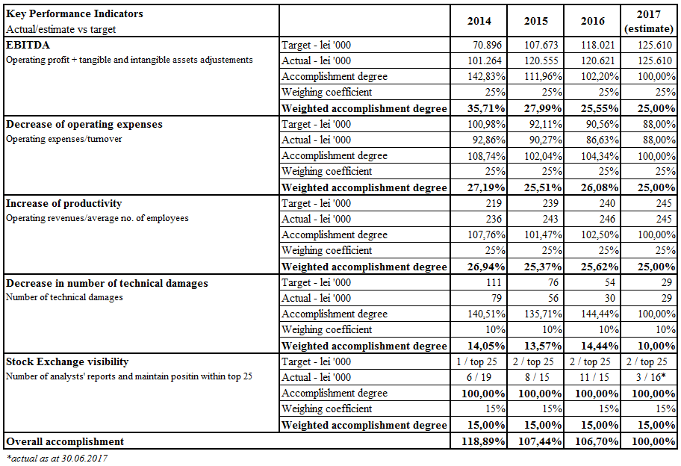
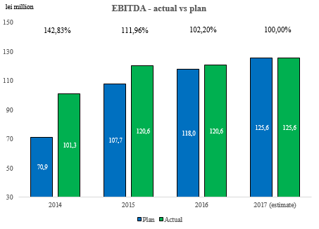

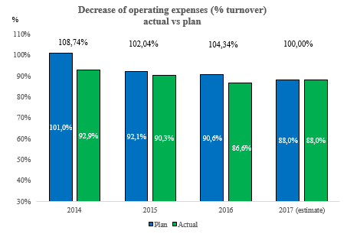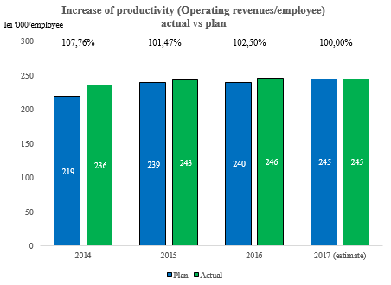
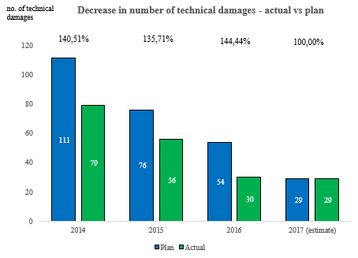
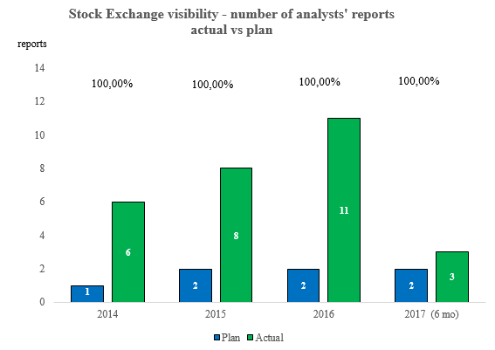

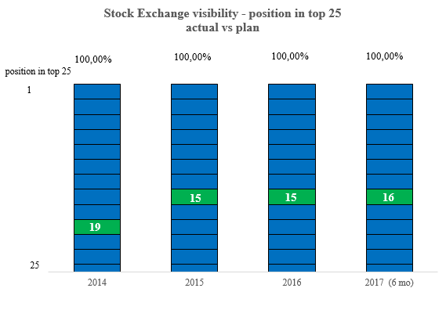

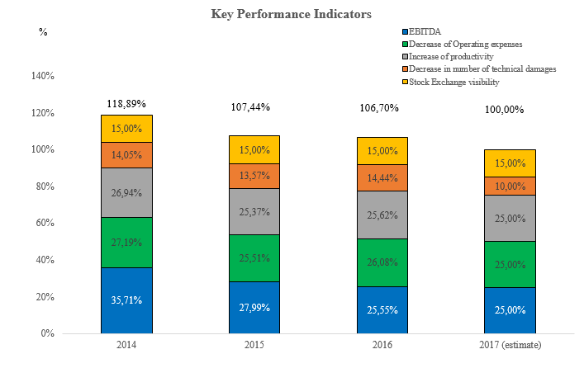

3. Results of activity in Advisory Committees

The Internal Regulations regarding the organization and functioning of Advisory Committees at BoA level of the company contain information on:
- Structure of advisory committees;
- Composition of advisory committees;
- Assignments of advisory committees.

The Advisory Committees created at BoA level are responsible for the carryin out of analyses and elaboration of recommendations for BoA in specific fields, and they present the BoA with monthly reports of their activity.
At the level of BoA the following Advisory Committees were created (their composition was presented in the first chapter of activity report) :
  - Audit Committee;
  - Nomination and Remuneration Committee;
  - Financial Committee for Relation with Investors;
  - Committee for Relations with Regulatory Energy Authorities;
  - Development Committee.

Advisory Committeesto which the following belong:
- Development Committee
- Committee for Relations with Regulatory Energy Authorities

The activity carried out with the other directors, members in these advisory committees, was constructive, analytical and in line with assignments established for each of these committees and mainly consisted of:
- Consultations regarding the materials/documents drawn up by different organizational entities from the structure of CONPET S.A – departments/divisions/services and forwarded to Committee;
- Analyses conducted based on reports/notes/information drawn up by specialized divisions from the level of executive management;
- Proposals/measures/recommendations to BoA following the analysis of documents presented.

The activities carried out at the level of Advisory Committees to which they belong had as main objective the following:
- approval ofincome and expenses budget and their substantiation notes to the Ordinary General Meeting of Shareholders;
- approval of Annexes no. 2 - 5 of income and expenses budget including the approval of their rectification, as applicable;
- approval of annual investment Programme (centralizing list and breakdown by objectives) and its rectification (general revision, with identification of adequate financing sources, integrated in the limits of values approved by the Ordinary General Meeting of Shareholders) ;
- regular monitoring of physical and value realization of annual investment Programme;
- approval of the annual Procurement Programme;
- regular monitoring of the stage of acquisitions in progress whose amount exceeds 100,000 lei, the situation of contracts signed/finalized with a higher value than 100,000 lei, the situation of finalized contracts with a value higher than 100,000 lei, the situation of utilities contracts in progress during each year;
- representation of company in relationship with the regulatory energy authorities;
- approval of materials related to the agenda of meetings of General Meeting of Shareholders;
- the regular information regarding the stage of fulfilment of measures disposed by decisions of BoA and the current activity of the company and the problem of deployment by technical, economic, legal components and other aspects;
- approval of preliminary financial statements for the fiscal years related to mandate period, accompanied by the list of contracts whose value is higher than 500,000 Euro/ acquisition (for goods and works) and respectively higher than 100,000 Euro/ acquisition (for services) ;
- approval of the result of annual inventory of assets which belong to the company and approval of the result of annul inventory of assets which belong to the public state domain;
- approval of decommissioning and valorisation by sale with auction of assets from the patrimony of the company;
- information regarding the fulfilment of measures disposed by the Court of Accounts of Romania – Chamber of Accounts Prahova, regarding the increase of share capital by the value of the 47 lands for which certificates were obtained for attestation of the ownership right over the lands;
- approval of annual financial statements drawn up for the fiscal years 2013 - 2016;
- elaboration of annual Reports of directors to the Ordinary General Meeting of Shareholders regarding the fiscal years 2013 – 2016, drawn up according to the regulations in force regarding the capital market, accompanied by annexes;
- approval of proposals to Ordinary General Meeting of Shareholders regarding the allocation of net profit for the fiscal years 2013 – 2016, fixation of gross dividend per share and payment date of dividends to shareholders, the submission of proposals for approval of the Ordinary General Meeting of Shareholders;
- elaboration of quarterly, semestrial and annual Reports of the General Manager for the year 2015, drawn up according to art. 54 of GEOno. 109/ 2011 for corporate governance of public enterprises;
- participation in the elaboration of the quarterly Report on the economic and financial activity of CONPET;
- identification of opportunities for development of company business and proposal of directions of action;
- approval of internal procedural Norms of acquisitions – review 2, updated and harmonized with Law no. 98/ 2016 and Lawno. 99/ 2016 for public and sectorial procurement, applied in CONPET;
- approval of semestrial Reports of the BoA to the Ordinary General Meeting of Shareholders on administration activity, drawn up according to art. 55 of Government Emergency Ordinance no. 109/ 2011 for corporate governance of public enterprises;
- regular analysis of list of critical infrastructure objectives of CONPET and security measures established;
- formulation of recommendations for the fields considered to have a strategic impact on the development of the company;
- approval of proposals to the Extraordinary General Meeting of Shareholders regarding the sale of company assets;
- monitoring of assurance of maintenance of national transport system, in correlation with the observance of technical norms for its exploitation;
- regular analysis of the situation regarding the evolution of cashflow related to the company;
- approval of Information to the Extraordinary General Meeting of Shareholders drawn up by the Strategic Projects Service regarding the vision of CONPET on the future perspectives of strategic development of the company for the period 2017 – 2025;

The Internal Regulations regarding the organization and functioning of Advisory Committees created at the level of BoA to which they belong include the following assignments:

DEVELOPMENT COMMITTEE
- assists the BoA in the fulfilment of responsibilities in the field of elaboration and updating of development strategy of the company;
- elaborates proposals regarding the strategy and development directions of the company on medium and long term;
- identifies the major development directions in the field on national and international level and makes recommendations for the major themes to be considered with strategic impact on the development of the company;
- elaborates proposals regarding the efficiency of development activity of the company;
- analyses the opportunities identified regarding the development of the company;
- analyses the fulfilment of strategic programmes of the company;
- informs the BoA regarding the efficiency of strategic programmes;
- regularly analyses the stage of fulfilment of investment programmes carried out by the company and proposes measures for improvement of activity in order to observe the deadlines for completion of objectives and works proposed;
- monitors the assurance of maintenance and modernization of national transport system and the observance of technical norms for exploitation and maintenance of production capacities;
- regularly analyses the observance of annual programme of acquisitions carried out by the company.

FINANCIAL COMMITTEE FOR RELATIONSHIP WITH INVESTORS
- monitoring of economic and financial situation of the company;
- transparency and increase in predictability of financial reports;
- recommendation of financing structure and efficient method of mobilization of resourcesin line with the administration plan;
- promotion and increase of company visibility on capital market;
- regular presentation of economic financial reports, respectively the observations made and sanctions applied by the authorities with right of financial and fiscal control over the company;
- examination at least once a year of the statement regarding the circulation of capital and evolution of cash flow of the company;
- decides, organises and participates in events which have the purpose to promote and increase the visibility of the company on the capital market;
- counsels the members of BoA and the Director General regarding the aspects of management and preparation of income and expenses budget, annual financial statements and semestrial accounting reporting and multiannual financial planning;
- assists and makes recommendations to the BoA from the point of view of financial reports and their relevance to different stakeholders including the capital market;
- informs the BoA on the financial implications regarding the management and administration of the company;
- analyses the materials for presentation of the company in external environment;
- makes proposals regarding the strategy and directions of approach of relationship with investors;
- monitors the meetings organized by the company with analysts and investors.

COMMITTEE FOR RELATIONS WITH REGULATORY ENERGY AUTHORITIES
- monitors the steps of the company to mthe regulatory energy authorities regarding the technical, legislative issues, etc. from its activity;
- monitors the fulfilment of obligations set out by the regulations related to the activity carried out by the company;
- analyses the proposals regarding the regulatory framework and forwards them to the BoA;
- monitors the collaboration relations with public authorities and gives assistance to the BoA in the management of collaboration policy.
- regularly analyses the list of critical infrastructure objectives of CONPET and the security measures established;
- assures the conditions for implementation of protection measures of all critical infrastructure objectives from the patrimony of the company or from the operator field;
- monitors own prevention and fight programmes against terrorism by optimal measures of physical and organizational protection, with recommendations in this respect to the BoA;
- can represent the company in the relationship with the regulatory energy authorities.

- Board of Administration in relationship with shareholders

The BoA is the main body which supervises the activity of the company and functions as buffer between the General Meeting of Shareholders and the executive management of the company represented by managers. The BoA is run by a chairman appointed by the General Meeting of Shareholders from among the members of the BoA. The Chairman of the BoA is not the Director General of CONPET S.A. The BoA delegated the management of the company to the Director General of CONPET S.A and the director general represents the company in the relations with third parties.

In the mandate period the number of meetings of BoA and General Meeting of Shareholders is presented in the following table:

YEAR | Number of decisions of the Board | Number of decisions of the Ordinary General Meeting of Shareholders | Number of decisions of the Extraordinary General Meeting of Shareholders
2013 | 18 | 6 | 1
2014 | 16 | 8 | 3
2015 | 15 | 5 | 3
2016 | 14 | 3 | 4
2017 | 12 | 3 | 1

Based on the strategy approved by Administration Plan, for the assurance of an efficient supervision of company management, guidelines of strategies were established by fields and policies of the company (operational policies, development policies, investment policies, human resources policies, commercial policies, code of ethics, code of corporate governance, policies regarding banking placements, work safety and health, relations with investors, public communication and social responsibility, etc.), designed to define the directions and methods of action for rendering efficient the activity of the company.

In order to get informed and substantiate the decisions in an efficient and adequate way, the BoA monitors every month the stage of fulfilment of measures disposed and regularly requests the executive management information/reports on the planning, budget execution and stage of realization of objectives established by Administration Plan, monthly reports on the stage of activities in departments/divisions, and other reports necessary for the exercise of supervisory function and control of executive management of the company as follows:
- semestrial and annual financial reports according to international accounting standards;
- Report on the execution of the mandate elaborated every quarter according to the provisions of GEO no. 109/2011, as further amended and supplemented;
- Report of statutory auditor;
- Report of internal auditor;
- Declaration of management regarding financial statements;
- Evaluation Report according to Internal Control/Management System; Corporate Social Responsibility Report (CSR);
- Declaration APPLY or EXPLAIN/Stage of conformity with the New Corporate Governance Code of BSE;
- regular reports drawn up every semester by heads of divisions and departments and heads of services.

The Board of Administration presents the General Meeting of Shareholders annual and semestrial reports on the activity carried out, as they are required by the provisions of GEO no. 109/2011, further amended and supplemented, the financial accounting legislation and the capital market.

The system of procedures instated for each of the procedural activities of the Company represents one of the efficient tools of supervision of its activity within the mechanism of monitoring and control of actions carried out for the materialization of objectives established.

The divisions of supervision and control of activity of the executive management of the company aimed at the main following fields of action:

Being run by a BoA composed of professional administrators with vast professional experience in the field, CONPET S.A. managed in the last four years to obtain remarkable economic and financial performances and to record an ascending trend regarding the development of activity and perfection of human resources who contribute to its realization.
The BoA usually meets at the company office whenever it is necessary, but at least every three months, at the summoning of the Board Chairman or at the request of two members of the Board or the Director General. In the meetings the BoA adopts decisions which lead to the efficient fulfilment of assignments by the administrative and executive management of the company.

In the exercise of assignments/competences incumbent on them by Articles of Incorporation and Admninistration Contract, the administrators of CONPET acted in the line of supervision and control exerted over the executive management, in the spirit of good practices of corporate governanceand professional deontology, with maximum responsibility, good faith and professionalism, thoroughness, seriousness, thorough control and made all diligences to achieve the objectives undertakenregarding the administration of the company during 2013-2017.

The main competences of Board of Administration are:
- summons the General Meetings of Shareholders of the company and establishes the agenda, approves the meeting materials;
- draws up the annual report which will be presented to the General Meeting of Shareholders, along with the annual financial statements and the report of financial auditor, and other reports imposed by applicable law, with observance of reporting requirements established by regulations of C.N.V.M./A.S.F. regarding the capial market and other incidental regulations;
- signs legal acts in the name and account of the company, by which it acquires assets for the company or alienates, leases, exchanges or establishes in guarantee assets from the patrimony of the company, whose amount exceeds half of the book value of company assetsat the date of conclusion of legal act, only with the approval of extraordinary general meeting of shareholders;
- subjects to the approval of the Ordinary General Meeting of Shareholders the Income and Expenses Budget of the company and the investment programme for the following fiscal year, and rectification of the Budget; approves the revision of investment programme within the same values;
- approves the organizational structureand the staff structure of the company, regulations for organization and functioning and internal regulations of the company;
- elaborates and submits to the approval of the Ordinary General Meeting of Shareholders the administration plan in the deadline set out by Government Emergency Ordinance no. 109/ 2011;
- appoints and revokes the general manager of the company and establishes his remuneration, whose general limits are set by the Ordinary General Meeting of Shareholders;
- establishes the objectives and performance indicators of the general manager and takes note regularly of their fulfilment degree;
- approves the global degree of fulfilment of objectives and performance indicators of the general manager, for the previous year, correlated with the financial statements of that fiscal year;
- establishes the main directions of activity and approves the strategies and development policies of the company;
- establishes the accounting policies and financial control system and approves the financial planning;
- proposes to shareholders on what market the securities issued by the Company will be quotedand selects the authorized independent registry company which keeps records of shares issued by the Company;
- fulfils all the necessary and useful acts for the realization of activity object of the companyexcept for those reserved by the law for the General Meeting of Shareholders;
- approves the proposals regarding the global development strategy, retooling and modernization strategy, economic financial restructuring strategy of the company;
- approves the management plan drawn up and presented by the general manager.

The Company prepares and disseminates regular and continuous relevant informationaccording to International Financial Reporting Standards (IFRS) and other reporting standards, respectively environmental, social and management standards. The information is presented both in Romanian and in English.

According to the calendar of financial communication with Bucharest Stock Exchange, the administrative and executive management of CONPET has organized and organises meetings with financial analysts, brokers, financial consultants and investors, both on the occasion of dissemination of financial statements and economic financial results, and other events from the activity of the company, which have impact on the quotation of shares.

The members of the BoA have taken and take decisions in the exclusive interest of the company and did not take or will not take part in the debates or decisions which create a confict between their personal interests and the company interests.

Each member of the BoA assures the avoidance of a direct or indirect conflict of interests with the Company and if such conflict appears, he/she will abstain from debates and voting on those matters, according to the legal provisions in force.

In view of assuring the procedural accuracy of transactions with stakeholders, the members of the BoA have in view the following criteria, but without being limited to these:
- keeping the competence of BoA or General Meeting of Shareholders, as applicable, to approve the most important transactions;
- requesting an opinion on the most important transactions from the internal control structures;
- entrusting the negotiations regarding these transactions to one or more independent directors or directors who do not have connections with stakeholders;
- resorting to independent experts.

The BoA establishes the corporate policy of dissemination of information, by observing the legislation in force and the Articles of Incorporation of the Company. This policy has to guarantee the equal access to information of shareholders, investors and significant shareholders and must not allow abuses regarding confidential information.

The social corporate responsibility represents an aspect of corporate governance by which we initiated at company level a series of actions which are socially responsible and beneficial for its image and with special positive public impact.
The essential role of CONPET S.A. in the field of transport by pipelines in Romania implies obviously the maintenance of a very good relationship with customers, with authorities, with all the entities which contribute permanently to the good functioning of its activity.

Given the successful implementation of private management in CONPET S.A, BoA decided to involve the company in the pilot projects initiated by the Government of Romania in the years 2015 and 2016, projects regarding the improvement of corporate governance and increase of transparency.

- SWOT ANALYSIS AND RISK MANAGEMENT

At the beginning of the mandate, following the realization of diagnosis analysis (SWOT) we identified risks for which we established control/mitigation measures on short, medium and long term, based on which we defined the strategic objectives for the period 2014-2017.

No. crt | RISK | Control/mitigation measures
1 | Operational risk (degradation of SNT as a result of low degree of use) | Redefinition of transport infrastructure depending on the perspective of request
2 | Operational risk (escalation of criminal phenomenon) | Discouragement of criminal phenomenon by introduction of a system for detection and localization in real time of leaks
3 | Market risk (transport of imported crude oil) | Interconnection of national transport system with other systems from the region
4 | Market risk (transport of crude oil in the country) | Development of related activities to basic activity
5 | Credit risk | No measures are necessary.
6 | Risk related to regulatory framework and authorizations | Steps for amendment of oil law and its harmonization with other applicable legal provisions
7 | Risks related to disputes | Steps for amendment of oil law, strengthening the control regarding the observance of internal procedural framework
8 | Legislative risks (increase of taxes and new taxes, reduction or suspension of fiscal facilities) | We will initiate a permanent systematic communication with the state representatives, the shareholders and all stakeholders for the integration of economic activity of the company in the national strategy, the energy field and branch to prevent to a higher extent the legislative risks.
9 | Legislative risks (loss of facility regarding security and protection of pipelines with police soldiers) | Introduction of the system for detection and localization in real time of leaks partially covers the risk of loss of facility of security assurance and protection of pipelines with police soldiers
10* | Risk determined by the evolution of global market | Development of related activities to basic activity
* For risk 10 the control measures are characterised by systematic and adequate communication with state representatives, shareholders and all stakeholders (Ministries, ANRM, authorities, customers etc) for the integration of economic activity of the Company in national strategy of energy field and branch.
Communication is in this case a preventive measure which may be the basis of subsequent prompt and adequate decisions with the final purpose of realization of strategic objectives established and undertaken.
In the current context, following the realization of diagnosis analysis (SWOT) of the Company, we identified the main strengths and weaknesses of CONPET.

Strengths
- natural monopoly on the market of transport of crude oil by pipelines;
- powerful shareholding structure on the capital market in Romania;
- very good performance in stock exchange;
- professional corporate governance structure;
- professional team and management performance;
- initiatives of diversification of basic activity;
- Experience >20 years in the company of 51% of employees;
- very good retention rate of employees;
- very good operational performance of company, with significant improvements in the last 3 years.

Weaknesses
- high costs of decommissioning of installations and preservation of unused pipelines;
- high degree of dependence on a limited number of customers
- high degree of dependence on the regulatory authorities who act as a referee;
- dependence on NAMR not only from point of view of regulating fees, but also to make decisions (e.g. decommissioning of pipelines, etc);
- configuration of network is quite extended and spreads on 24 counties;
- advanced age of employees – average age: 49 years old;
- Lack of performance indicators for employees;
- IT vulnerability by exposure of the system to a third party.

Opportunities
- rendering efficient the activities – renegotiation of contracts with suppliers (e.g. telecommunications, electricity, gas);
- Optimization of the company’s capital structure and improvement of the return on employed Capital, by distribution of unemployed cash to the company’s shareholders;
- Definition of the company as a strategic player at regional level by interconnection of National Oil Transport System with the zonal systems;
- provision of storage services of crude oil and oil products;
- Diversification of basic activity;
- possible financing at a competitive cost of the Company, being a company listed on stock exchange with access to various sources of capital;
- Possible favourable legislative changes;
- Possibility of outsourcing certain services.

Threats
- Risk of portfolio of customers (e.g. the possibility at a given moment to relocate the activity of Lukoil refinery from Romania);
- Lack of interconnection of transport system with neighbouring systems;
- Degradation of the National Transport System by pipelines as a result of the low degree of use;
- strategic decisions with major impact (potentially disruptive) of the 3 main customers: OMV Petrom, Lukoil and Rompetrol;
Correct identification of risk position in the risk matrix is essential for the strategic decisions of the company
- Oil Law – lack of changes and lack of a distinctive regime for transports by pipelines.

Risk matrix of CONPET

As a result of this diagnosis analysis we identified a number of 11 significant risks, as you can see in the chart below.

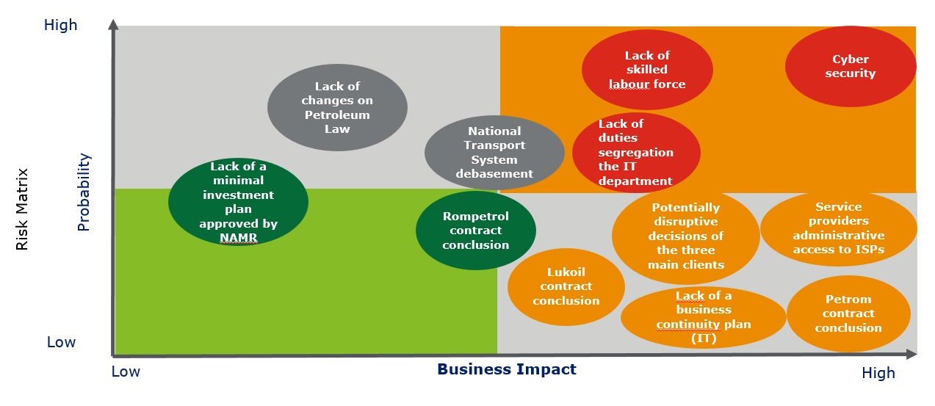
Fig. 5 Risk matrix CONPET

Cybernetic security and lack of workforce are the risks with high probability of occurrence and at the same time with high impact on business. Other risks with a high probability of occurrence are degradation of National Transport System and unchanged maintenance of oil law. Among all the risks identified, the highest impact on the company activity represents the possible disruptive decisions of OMV Petrom.

- Internal control management system, component of integrated management system

According to OSGG 400/2015, amended by OSGG 200/2016, the leader of the public entity disposes by taking account of internal control management standards, the control measures necessary for the implementation and development of internal control management system, including for updating of risks registers and formal procedures by processes or activities.
Managementul calității
ISO 9001:2008

Integrated management systems implemented
Quality Management System
ISO 9001:2008
Quality Management
ISO 9001:2008
Environment Management
ISO 14001:2005
Energy Management
ISO 50001:2011
Internal control management and risks management
OSGG 400/2015 further amended and supplemented
Railway Safety Management
Directive 2004/49/CE
Occupational Health and Safety Management OHSAS 18001:2008
In national premiere, in the companies with majority state-owned capital an energy management system was implemented according to SR EN ISO 50001:2011

Figure 6 – Management systems implemented

The management systems implemented according to requirements of ISO standards are externally evaluated and certified by the international body DNVGL and for railway safety according to European Directive transposed in national legislation, by ASFR.

By implementation of quality management system, CONPET proves the capacity to provide services which fulfil both the requirements of customers and the legal requirements and applicable regulations and are in line with the strategic objectives established in the Administration Plan.

The implementation of the environment management system allows Conpet not only to meet expectations regarding its environmental performance, but also to control costs and comply with environmental legislation and environmental regulations. The activity of evaluation of impact on environment is carried out in the production sectors whenever there appear changes in the transport system. The aspects with significant impact identified are at the basis of elaboration of Environment Management Programme and Plan of actions for fulfilment of environmental objectives.
The Energy Management System has the purpose to create the opportunity for Conpet to follow a systemic approach for continuous improvement of energy performance, respectively energy efficiency and the method of use of consumed energy.
Internal Control Management is a management system oriented to the realization of performance by management of operational risks identified for realization of specific objectives, correlated with the strategic objectives of the Board of Directors.
OHSAS 18001:2008 leads to the minimization of risk for employees or other persons who work for or in the name of CONPET and proves our preoccupation for increasing the occupational health and safety.
According to Directive 2004/49/CE, transposed in Law no. 55/2006, since 2012 CONPET has implemented and maintained the certified system AFER-ASFR for management of railway safety. Thus, the company commits to act for achievement of common safety objectives and observance of requirements set out both by technical interoperability specifications and by national safety regulations.

Internal Control Management
For the purpose of implementing the provisions of Order no. 400/2015 for approval of Internal Control/Management Code of public entities, further amended and supplemented the Internal Control Management System Monitoring Commission was created by Decision of General Manager.
Each member of Monitoring Commission is responsible for the fulfilment of tasks from the development programme of management control systems and observance of deadlines established.
The Public Internal Audit Office counsels the Monitoring Commission and participates in its meetings. The Public Internal Audit Office monitors the activities of Monitoring Commission until the full implementation and for the maintenance of internal control/management system and systematically informs the General Manager on the activity of Monitoring Commission and the problems faced by this commission and which can affect the process of implementation and maintenance of internal control/management system.
By Decision of Director General of CONPET S.A. the Risk Management Team was created in CONPET S.A
Development programme of internal control/management system

The development programme of internal control/management system of CONPET is analysed every year, after the self-evaluation of implementation degree according to OSGG 400/2015, further amended and supplemented.
Figure 7 – Organizational structure of internal control management system of CONPET S.A.
BOARD OF DIRECTORS

AUDIT COMMITTEE

GENERAL MANAGER

MONITORING COMMISSION
SCI/M

Management /Internal Control Systems SERVICE

PUBLIC INTERNAL AUDIT SERVICE

EGR CONPET

EGR Divisions/ Departments/Services/ Offices directly subordinated to General Manager

The Monitoring Commission has elaborated and approved the Code of ethics of the company CONPET, an ethics counsellor is appointed by decision of general manager and the organization staff has signed an individual commitment of observance of ethical conduct and integrity rules contained in the Code of Ethics.
According to the provisions of system procedure ”Establishment of CONPET objectives”, the SMART objectives are established at the relevant levels and functions.
For the establishment of specific objectives we envisaged the mission of organization and strategic objectives from Administration Plan 2014 –2017, we also took into account all the general objectives defined in SMI documentation, according to requirements of reference standards. We identified and evaluated every year the risks of non-realization of objectives and have established control measures for their mitigation, according to the provisions of system procedure „Risks Management”.
The processes identified since 2007 in the implementation of integrated management system and formal procedures by activities were valorised as control instruments, elaboration and implementation of new procedures for the activities with risks, which is a practice recognized by all the employees.
Stage of implementation of internal control/management system

The Company self-evaluates every year the implementation degree of international control standards and reports it according to the legal requirements.
In the year 2016, following the evaluation of internal control/management system according to the provisions of OSGG 400/2015, further amended and supplemented, it was declared partially compliant with 14 implemented standards, 1 standard partially implemented, 1 standard not implemented.
The report of the internal control/management system of 31.12.2016 is enclosed to the annual Financial Statements.

The results of self-evaluation were also transmitted to guardianship authority.
Certified integrated management systems
The certification of the integrated management system quality – environment – occupational health and safety took place for the first time in September 2007, with rectifications every three years, in September 2010, September 2013 and September 2016. Supervisory audits take place every year.

Following the external audit carried out by the body DET NORSKE VERITAS-GERMANISCHER LLOYD, in September 2016, we maintain the certificates:
- 179568-2015-AQ-ROU-RvA, according to requirements SR EN ISO 9001:2008,
- 179569-2015-AE-ROU-RvA, according to requirements SR EN ISO 14001:2004,
- 179565-2015-AHSO-ROU-RvA, according to requirements SR OHSAS 18001:2007.
In September 2016 the energy management system was certified according to requirements SR EN ISO 50001:2011, implemented and integrated with the previous management systems.
Following the external audit carried out in September 2016 by the body DET NORSKE VERITAS-GERMANISCHER LLOYD, the following certificate was issued:
- 207619-2016-AE-ROU-RvA, according to requirements SR EN ISO 50001:2011.

Although we are a company which holds the monopoly of transport of crude oil, gasoline and condensate by pipelines, we are receptive to the needs of our customers who place their property (crude oil, rich gas, condensate etc) in our care.
By the mutually advantageous contractual relationship, the customers have the confidence and certainty that they receive on time and completely the product transported where they need it. The transport service we make available to our customers must be safe and efficient.
The quality, environment and occupational health and safety policy is oriented to the satisfaction of requirements of our customers and legal requirements and aims at the following directions of action:
- assurance of availability and promptness of our transport services;
- operative resolution of interventions at the transport installations without affecting the interests of customers and other stakeholders;
- optimization of technological consumptions of transported product;
- conformity with the legal requirements and other applicable requirements regarding the environmental aspects and risks of accident and occupational illness;
- continuous improvement of performances in the environmental protection activity especially by adoption of measures of prevention of pollution, technological risks and accidents which can have negative consequences on the environment;
- awareness of own staff and the staff who works in the name of organization and improvement of communication for the assurance of an active participation in the realization of objectives;
- prevention and reduction of risks of occupational illness and accidents at workplace;
- consultation of employees regarding any aspect of occupational health and safety;
- assurance of adequate organizational framework for establishing the objectives of integrated management system of quality – environment – occupational health and safety;
- permanent evaluation of risks/opportunities generated by the context in which the organization evolves and risks/opportunities related to processes and establishment of actions for their treatment.

Since 2010, the Railway Safety Management System was integrated according to requirements of Directive 2004/49/CE, transposed in Romania by Law no. 55/2006 for railway safety. The field of application of this system contains the railway maps in which CONPET makes railway manoeuver operations.
By the railway safety policy, CONPET commits to act for achievement of common safety objectives and observance of requirements set out both by technical specifications of interoperability and by national safety regulations.
For the railway ramps, the Romanian Railway Authority (AFER) gave the Company the Licence for performance of railway transport services (railway manoeuvre) and the Safety Certificate Part A (railway manoeuver).
Within the energy management system we approved the document ”List of objectives and energy targets for the year 2016” which contains the following objectives and targets:
Energy objective | Energy Target
O1: Increase of energy efficiency for significant uses of electricity | O1/T1:Reduction of electricity consumption at CONPET level by 4.05% compared to the reference period 2014
O2: Increase of energy efficiency for significant uses of natural gases | O2/T1: Reduction of consumption of natural gases in CONPET by 5.00% compared to the reference period 2014
O2: Increase of energy efficiency for significant uses of car fuel | O3/T1:Reduction of consumption of fuels in Car Park by 15.46% compared to the reference period 2014

We also drew up and approved the document: “Plan of actions for achievement of objectives and energy targets”. The document was recorded with no. 35083 of 06.10.2016.
All the actions from “Plan of actions for achievement of objectives and energy targets” with deadline 2016 were made. These actions are:
- modernization of external lighting system with use of sources in LED technology – in locations: Imeci, Siliște, Marghita, Salonta, Dragoș Vodă, office 1 Ploiești
- replacement of transformers (in the stations Poiana Lacului and Lucăcești)
- replacement of air conditioning systems in office 2 by inverters energy class A++
- modernization of car fleet by GPS system.

For the year 2017 we drew up and approved the document: “Plan of actions for achievement of objectives and energy targets”. The document was recorded with no. 22909 of 09.06.2017.
The stage of realization of actions due in 2017 is as follows:
- Modernization of external lighting systems by use of sources in LED technology West, East, South and Import Divisions – we completed the works in 3 locations (Băicoi and Bărbătești – station and ramp). We are executing works in 14 locations: Poiana Lacului, Cartojani, Videle, Moreni, Urlați, Cireșu, Independența, Țicleni, Orlești, Otești, Biled, Pecica, Constanța South, Călăreți.

- replacement of Worthington pump 2,5 kWh by Ebara pump 1,7 kWh in station Constanța South - completed

- Modernization of pumping system in locations Moreni, Oprișenești, Cireșu – Execution Contract signed in August 2017.

- metering of electricity consumption by types of uses (by use of tele-management system) For the 9 locations to be made in 2017 we are working on the tender book regarding the design and execution of works. We have made the local metering in the point of work Conpet from Lukoil Refinery.

- Modernization of heating plant and district heating network Marghita – Execution Contract signed in July 2017, the works are in progress.

- Thermal rehabilitation of heated buildings in station and ramp Bărbătești – tender book approved by CTE
All the actions in progress are budgeted and included in Investment Programme for the year 2017.

Internal Audit of Integrated Management System

The internal audit provides information on the conformity with requirements of referentials and legal requirements applicable. The internal audits were carried out according to the programme approved every year and the audit criteria established in Audit Plans. The results were communicated to the auditees by dissemination of Audit Reports, to which we enclosed the Nonconformity and Corrective Action Reports (RNAC/P) opened during the audits and management in the meetings of analyses conducted by management.
The Company assures every year resources for the carrying out in good conditions of internal audit, compulsory requirement of reference standards SR EN 9001:2008, SR EN ISO 14001:2005, SR OHSAS 18001:2008 and SR EN ISO 50001:2011.
7. Financial performances during mandate

The main economic financial indicators during mandate (2014-2017) and reference year - 2013

The results and annual financial indicators corresponding to the period of Administration Plan are presented and analysed by comparison with the year 2013, considered reference year.
During the period 2014 – 2017 the company recorded positive financial results reflected both in the robust financial position and in high profitability.

Evolution of the main economic financial indicators

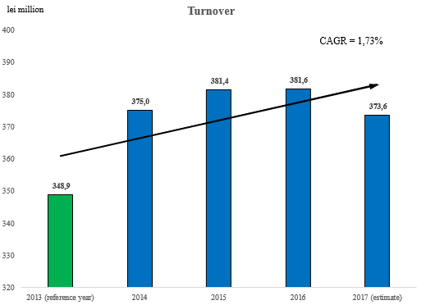
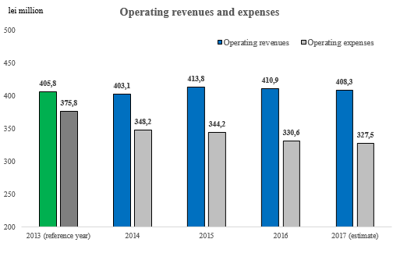
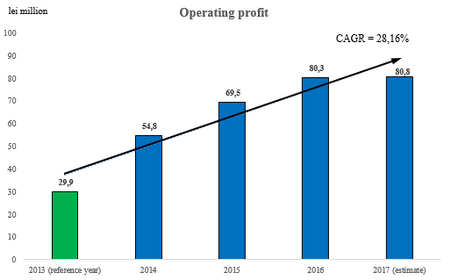

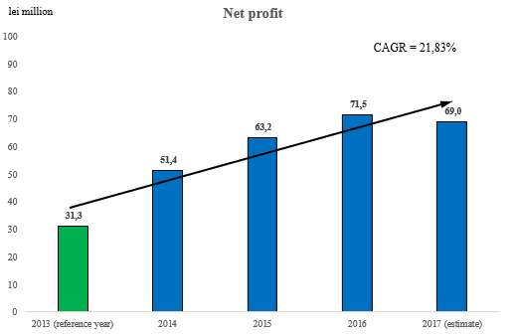

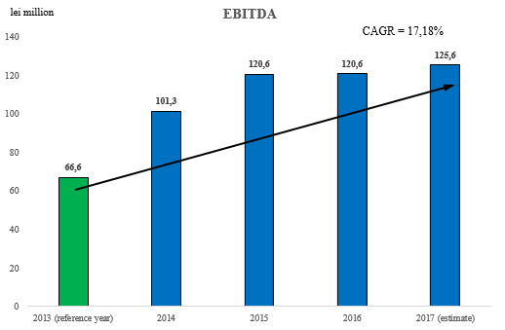

The increase of operating income and continuous reduction of operating costs had as result positive evolutions compared to reference year of operating profit, net profit and EBITDA (operating profit + value adjustments regarding the fixed assets).
Detailed information about the economic financial results and performance indicators can be found in the Annual Report of directors and in annual Financial Statements drawn up according to IFRS-EU, public documents, posted on the company website.
The evolution of performance indicators taken into account in the calculation of variable component of administrators' remuneration according to the targets established in administration contracts is presented in the table below.

8. Investments – development during 2014-2017

The investment projects of CONPET aim first of all at increase in efficiency of transport activity. The investment capacity represents the essential parameter of force and credibility of the company, the ratio between the investment volume and turnover, capitals and profits obtained are eloquent in this respect.
CONPET finances the investment activity from modernization quota and other own financing sources which offer the company a total degree of financial autonomy, and the company does not need to resort to loans.

From the modernization quota the Company finances investment objectives in rehabilitation, modernization and development programmes agreed with the National Agency for Mineral Resources according to “The oil Agreement for concession of operation of national transport system of crude oil, gasoline, condensate and ethane, including main pipelines and installations, and related equipment”.

The exploatation of the national transport system of crude oil, gasoline, condensate and ethane is regulated by Oil Law and is executed based on Oil Concession Agreement signed and approved in the year 2002 by GD no. 793, between S.C. CONPET S.A. and the National Agency for Mineral Resources, which is the competent authority which represents the interests of Romanian state in oil field.

The Company adopted a planning strategy and gradual execution of replacement works and assets modernization by annual and multiannual programmes which assure a balanced financial effort every year, correlated with resources and available capacities for deduction and execution/monitoring of works.
The investment policy of CONPET is closely correlated with the oil transport activity and establishes he basic principles considered in evaluation and promotion of investments.

The synthetic situation of investments made during the period 2014-2017 is as follows:

Realization of investment programme 2014 – 2017 semester I by fields:
 |  |  | thousand lei
No. crt. | Name of objective | Achieved | Scheduled
 | Total general, of which: | 128.820 | 177.996
1 | YEAR 2014 | 30.520 | 50.000
 | -investments related to public domain | 24.780 | 43.391
 | -investments in operator domain | 5.740 | 6.609
2 | YEAR 2015 | 38.173 | 51.912
 | -investments related to public domain | 25.737 | 37.532
 | -investments in operator domain | 12.437 | 14.380
3 | YEAR 2016 | 45.408 | 56.976
 | -investments related to public domain | 36.870 | 42.578
 | -investments in operator domain | 8.538 | 14.398
4 | YEAR 2017 Sem. I | 14.719 | 19.108
 | -investments related to public domain | 11.695 | 16.834
 | -investments in operator domain | 3.024 | 2.274

Millions lei
Fig. 8 Value of investment works done during 2014 – 2017, semester I

Fig. 9 Value of investment works – commissioning by years and financing sources

The realization in a proportion below 100% of investment programmes was mainly due to difficulties faced by the company in the process of obtaining approvals from owners and building permits.
Delays generated by:
- Authorization/Approval of works – the issue with unjustified delay of permits/approvals issued by Administrators of assets which belong to the public domain of national or county interest and the Urban Planning Certificate/Building Permit or Specialized Approvals;
- acquisition of the right of use of lands - conditioned access for the execution of works on lands private property, lands state property: in relationship with C.N.A.D.N.R., CF, R.N.P. ROMSILVA/ C.R.S.C.;
- bad weather conditions.

For example, obstacles with repetitive nature:
- Problems with lands granted in concession by the Mayor's Office;
- Refusal of owners to sign land lease agreements.
These difficulties listed above lead to the impossibility to estimate the building permit obtention.
In the authorization activity of works execution we encountered a series of difficulties, especially legislative nature, which led to delays in the realization of works for components S.N.T.C.

The main cause which generates delays in the execution of works represents the lack of a legal regulation which clarifies the right of use and legal easement free of charge in case of oil transporter similarly to gas transmission.

The maintenance of the legal framework provided nowadays by Oil Law creates financial opportunities to land owners, CONPET can grant significant amounts for conclusion of agreements for access to land in view of execution of works.

Without a legal provision which allows facilities in obtaining permits and approvals, CONPET encounters difficulties in obtaining in a reasonable time building permits and sometimes we could not obtain them.

Another cause for non-realization of value of investment programme represents the differences between the estimated values and the contracted values:
- The Chapter Miscellaneous and Unpredictable represents maximum 10% of the value of design and execution contracts, value included in investment programme which can be or not be consumed.
- The value estimated by design engineer exceeds the value resulted from contracting procedures.

For the realization of its object of activity, the transport of crude oil, gasoline and ethane, from and to all its business partners, in maximum operative conditions, with high efficiency and lower operating costs, observing the legislation in force for environmental protection, work safety, and the other normative acts in the field, CONPET S.A. carries out a sustained activity regarding the improvement of the technical condition of the national transport system.

Rehabilitations of pipelines during 2014 – semester I 2017
 |  |  |  |  |  | thousand lei
No. crt. | Name of objective | 2014 | 2015 | 2016 | 2017 Sem.I | TOTAL
 | Total general, of which: | 30.520 | 38.173 | 45.408 | 14.719 | 128.820
1 | Rehabilitations of pipelines PUBLIC | 13.179 | 15.040 | 25.653 | 8.467 | 62.339
2 | Rehabilitations of pipelines OPERATOR | 1.002 | 799 | 175 | 911 | 2.887
3 | Other works PUBLIC | 11.601 | 10.697 | 11.217 | 3.228 | 36.743
4 | Other works OPERATOR | 4.738 | 11.638 | 8.363 | 2.112 | 26.852

Fig. 10 Value of rehabilitation works of pipelines carried out during 2014-2017, sem. I

Replacements of pipelines during 2014 – semester I 2017
No. | Replaced pipeline | km  achieved | km  scheduled
 | TOTAL of which: | 90,93 | 102
1. | 2014 | 18,60 | 26
2. | 2015 | 28,87 | 33
3. | 2016 | 24,23 | 24
4. | 2017 Sem.I | 19,23 | 19

Fig. 11 Km. of replaced pipeline during 2014 – 2017, semester I
By analysing in correlation the number of km of replaced pipeline and number of damages recorded during the period 2014 – 2017, sem. I, the situation is as follows:

DAMAGES OF PIPELINES 2014 – 2017 sem I
Year | Total | Technical damages | Caused damages
2014 | 115 | 79 | 36
2015 | 74 | 56 | 18
2016 | 45 | 30 | 15
2017 sem 1 | 25 | 20 | 5

Fig. 12 Total number of damages caused during 2014 – 2017, semester I

We can see that as a consequence of permanent preoccupation for increasing the safety in operation of transport system and improvement of its technical condition, the number of technical damages recorded in the year 2016, compared to the year 2014 decreased by 62%, from 79 to 30 damages.
Also, the number of damages caused decreased by 58 %, from 36 to 15. The situation by total damages, technical and caused, presents a decrease by 61%, from 115 to 45.
The most important investment works carried out during 2014 – semester I 2017 were:
- Modernization and monitoring of cathodic protection system at central and sector level, for the pipelines for transport of crude oil in the country and import
During this period we finalized and commissioned cathodic protection systems in 39 locations, in amount of 9,250 thousand lei.
We are also carrying out an execution contract for the installation of cathodic protection systems in 51 locations with finalization deadline in 2018.
- Tank R2 Călăreți – completed and commissioned, with a value of 2,898 thousand lei.
- safety works for Argeș River crossing, Căteasca area, Argeș county – completed and commissioned, with a value of 19,516 thousand lei.

- Modernization of radio relay microwave lines + introduction of location Cireșu in telecommunication system, stage 2 – completed and commissioned, with a value of 2,830 thousand lei.
- Modernization of installation PSI Imeci – completed and commissioned, with a value of 1.994 thousand lei.
- Upgrade of SCADA system – completed and commissioned, in amount of 2,933 thousand lei.
- Inspection with smart go-devil of threads under Danube and Borcea 7 threads x 1800 ml 7 threads x 1400 ml and pipeline 14 inch Poarta Albă-Călăreți – completed and commissioned, with a value of 4.462 thousand lei.
- replacement of pipeline 28" Constanța-C1 on a total length of 10145 m – 13 sections completed and commissioned, in amount of 8,936 thousand lei; in progress 4 sections.
- replacement of pipeline 24" Bărăganu-Călăreți on a total length of 16295 m – 12 sections completed, of which 3 commissioned, with a value of 3,629 thousand lei; 1 section with problems in execution because of the refusal of land owner to allow access.

During this period the investment works proposed were executed even if there were delays compared to the initial schedule. The reasons of delays in the execution of works were of objective nature, being presented above.
Given the above we can consider that the technical condition of the national transport system of crude oil by pipelines, operated by CONPET, is adequate and the modernization effort for the future must focus on components such as: leak detection system and optimization of SCADA system and și upgrade of hardware and software of remote transmission unit RTU.

Thanks to the improvement of the system we can notice:
- reduction of technological losses in the process of storage and transport;
- increase of performances of measure and control system for quantities of transported crude oil;
- increased quality of services by the use of the state-of-the-art crude oil fiscal measurement system;
- improvement of safety in exploitation and increase in flexibility of transport system;
- minimization of energy consumptions and expenses for maintenance and operation of the system;
- minimization of operating costs and reduction of difficulties in operation;
- reduction of ecological impact on environment;
- assurance of functioning of pipeline for transport of crude oil and gasoline in safe conditions and at designed parameters;
- elimination of the risk of occurrence of technical accidents with major impact on environment, the programme of crude oil supply for refineries;
- avoidance of risk of occurrence of wide-scope environmental accidents.

9. Self-evaluation and conformity of activity of Board of Administration with requirements of Corporate Governance Code of BVB

Because performance represents the objective result of administration, supervision and control on executive management, in the vision of administrative management of CONPET S.A., along with an efficient strategic vision we defined the strategic directions for its materialization.
The special professional competences, vast professional expertise and the capacity to control the visible and invisible dynamics of the team, its psychology, are only a few of the aces of private administrative management of CONPET S.A.
The current BoA managed to substantiate very important and efficient administration and management plans regarding the monitoring at organization level with the result of optimization of activity efficiency and business development in the context of a continually changing internal and international environment.
In the vision of private management of the company, the use of modern tools for operationalization and measurement of performances, the tools used with success in strategic management will allow for efficient monitoring of action directions established for achieving the strategic objectives regarding the administration of the company during 2013-2017.
The BoA analyses based on monthly reports the stage of measures disposed by the decisions of the Board, which represents an important method of work for the monitoring of company activity regarded in relation to dynamics of requirements of role and assignments of the Board, so that the decisions made in administration of the company are timely, efficient and competitive.
In the annual Report of Administrators, report which is subjected to the approval of the Ordinary General Meeting of Shareholders (OGMS) with the annual financial statements, the administration activity of the company is presented in detail compared to objectives undertaken by Administration Plan. In this deadline, according to the legal provisions in force, the directors of the company submit to the Ordinary General Meeting of Shareholders the discharge of management, approved every year for the whole mandate period.
The structure of the BoA of CONPET S.A. assures a balance between the non-executive directors and the executive director, so that no person or restrained group of persons can dominate the decision-making process of the BoA, which is and will remain its collective responsibility, the Board being jointly liable for all the decisions made in the exercise of its assignments and competences.
The members of the BoA always update their knowledge and improve their expertise regarding the activity of the company and the application of the best corporate governance practices for the fulfilment of their roles.
According to the provisions of the updated Articles of Incorporation of the Company, the Chairman of the Board is appointed from among the members of the Board for a period which cannot exceed his term of director. The Chairman of the Board of Administration (BoA) is not the general manager of the company.
I, the undersigned Liviu Ilași, was elected Member of the BoA of CONPET SA by Decision of the Ordinary General Meeting of Shareholders no. 6/ 28.11.2013 and was appointed Director General of CONPET S.A. by Decision no. 17/ 06.12.2013. The period of director mandate is 4 years. My mandate began on 29.11.2013 and ends on 28.11.2017.

The strengths envisaged in my appointment as Director General are:
- technical expertise and professional expertise in administration and control/management of important companies listed on the stock exchange;
- Creativity, work power, desire of involvement and force of undertaking the responsibility for administration of a large company, team spirit;
- strategic vision and personal vision regarding the future of this company and its role as player in the national and regional energy system;
- good capacity of evaluation of company results and identification of opportunities and possibilities of business expansion and diversification;
- training and professional experience in energy field regarding the administration of companies;
- excellent capacity of institutional and interpersonal communication both within the Board of Directors and in its relations with the executive management and stakeholders of the company;
- Ability to develop and maintain an efficient, dynamic relational system suited to the specificity of company activity;
- Capacity to assure a precise delimitation between the roles and assignments of the Board of Directors and those of executive management;
- determination which characterises me, my capacity of good organiser, dynamism, communication and dialogue skills;
- Creativity, work power, desire of involvement and force of undertaking the responsibility for administration of a large company, team spirit;
- independent judgment in making decisions, critical and constructive reasoning, collective responsibility;
- the desire of surpassing my own limits and innovation.

As for the activity I carried out in the mandate 2013-2017, as executive administrator (member of the Board of Administration and Director General) of CONPET S.A., I mention that it was carried out:
- in compliance with the legislation incidental to activity sector, in the best interest of the company and its performance;
- in a professional, competent manner, seeking performance and excellence in business;
- with good faith, loyalty and with the mandate of a good administrator of state patrimony and other shareholders; in the spirit of the best corporate governance practices ;
- in transparent, prudent manner and with maximum responsibility and seriousness;
- with observance of ethical standards and moral and professional integrity;
- by total involvement and undertaking of tasks and projects with a national and international strategic scope;
- in effective way based on consensus and efficient communication both in the actions carried out in the decisions made in the administration of the company;
- in sustainable way by remodelling and business development, by strategic repositioning of the company, which became an important actor on the European, regional and international energy stage.

The BoA of CONPET SA acted collectively, in unitary way, according to the legal provisions in force and strictly observed the terms of mandate and the commitments undertaken regarding the administration of the company during the period 2013-2017.

In summary regarding the architecture, competence and activity of the current BoA of CONPET S.A. we can mention that:

- the members of the current BoA have a wide experience and expertise in control and administration of companies listed on BSE, demonstrated strategic vision, moral and professional integrity, the skills to decide efficiently;
- each member of the Board has the qualification and necessary skills to evaluate correctly and efficiently the operations and policies of the company in different fields of action and the determination to make the optimal decisions;
- the directors act in a competent and professional way in line with the legislation incidental to the sector of activity, in the best interest of the company and its performance;
- the members of the BoA of CONPET SA know and understand very well the role they have in administration of the Company and that is why, they act with their maximum competence, professional training and determination for undertaking and fulfilling this role;
- the composition of the Board is balanced regarding the professional experience and technical/economic/legal expertise;
- the directors supervise and control the executive management and the activity of the Company;
- by their expertise and their skills they guide the executive management in the efficient realization of tasks and assignments;
- each director acts independently, critically and constructively in relationship with executive management; the members of the Board complete one another, having a very good collaboration between them and with the executive management.

10. Innovation and creativity
10.1 Increase of CONPET visibility on external markets

For consolidation of the brand image of CONPET on the capital markets of Romania and abroad, for the expansion of activity at regional and European level, during the period 2014 - 2017 we tackled new methods of promoting the company, our reputation being decisive in this direction. As novelty elements, we will highlight:
- successful realization of 29 major events, which carry the positive image of the company such as:
- the visit received by the top management team of the largest foreign shareholder, UTILICO EMERGING MARKETS, which holds the largest number of shares in CONPET after the Romanian state - 21 September 2016;
- an unique event in the Romanian oil history – “CONPET Jubilee – 115 years of transport of crude oil by pipelines, 25 years of modern existence of the Company” (22 January 2016);
- the official visit of the Group of Ambassadors and African Consular Missions accredited in Romania (Kingdom of Morocco, Republic of Tunisia, Arab Republic of Egypt, Democratic People's Republic of Algeria, Republic of Sudan, Democratic Republic of Congo, Republic of Ghana), seven ambassadors and high officials at the office of CONPET ( 6 December 2016);
- Symposium „Anghel Saligny, visionary of oil industry in Romania” ( 27 January 2017);
- the official visit of the Diplomatic and Consular Body of Romania led by the Minister of Foreign Affairs, Mr. Teodor Meleșcanu, on the occasion of Diplomacy Day, 80 ambassadors and consuls of Romania abroad at the office of CONPET (1 September 2017);
- promotion of activity, results and major projects of CONPET, by launch in 2015, of a new website, www.conpet.ro, and permanent update of information for development of a transparent relationship with all the categories of stakeholders (http://www.conpet.ro/guvernanta-corporativa, http://www.conpet.ro/relatia-cu-investitorii/ , http://www.conpet.ro/category/achizitii/ , http://www.conpet.ro/noutati/ );
- a new activity of The Communication and Public Relations Department since 2016, realization of daily press monitoring reports, which are transmitted in real time to the management team and monthly and semestrial reports of qualitative and quantitative evaluation of local and national appearances of the company in the media.
Thus, CONPET recorded during 2016, the largest media coverage in online environment, respectively 397 out of total 563 references (71% of total references).
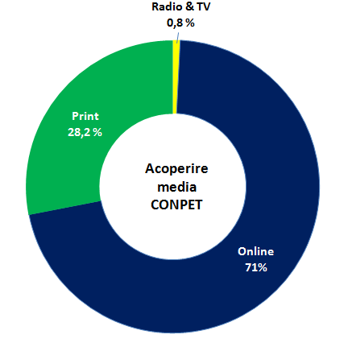
Fig. 13 Press monitoring of CONPET in the year 2016 – media coverage

As for the segmentation by sources of media information, their weight is as follows:
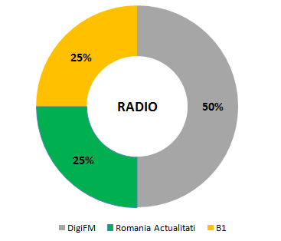
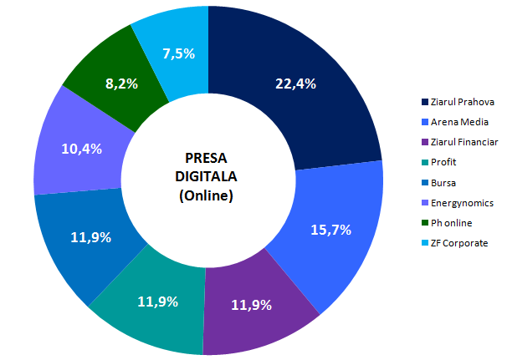
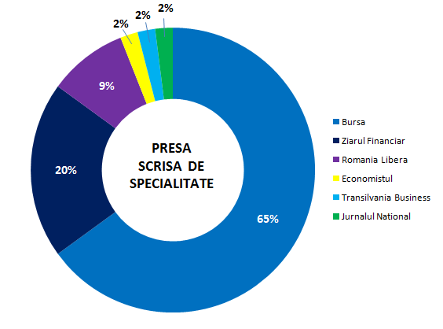

Fig. 14. Press monitoring of CONPET in the year 2016 – segmentation of information sources

Out of total 563 references, 12% were considered favourable, in 87% CONPET had a neutral image, while only 1% were unfavourable.
Other novelty elements for CONPET, which contributed to the increase of company visibility, since 2016 are:
- realization for the first ime in the CONPET history of products for audio/video presentation and promotion, including for the international business environment, two films: „CONPET - Uniqueness and tradition for over 100 years” and „CONPET – Energy for Romania”, a TV advertising spot and radio advertising spot;
- realization and premiere launch of Facebook page of CONPET - an efficient method of making the company values known and increasing the brand reputation and notoriety;
- organization of photographic exhibitions in premiere on the ground floor of headquarters of the company:”CONPET – from archaic to modern”; ”Africa in images”.
- organization of events with image representatives from the cultural field and remarkable personalities in education.
Given the objective of increasing the visibility of the company on external level, since 2015 CONPET has extended collaboration with non-governmental organizations. Thus, CONPET became member of organizations with international impact, such as:
- Romanian Energy Centre (CRE), which carries out its activity in Brussels
- the Romanian National Committee – World Energy Council;
- AmCham - American Chamber of Commerce in Romania since 2016.

10.2 Identification and development of strategic human resources projects
For the purpose of strengthening the role of human resource function in organization, since 2016, the Human Resources Department carried out research activities in view of identifying and developing short-term and medium-term strategic projects for the implementation of a planning system of human resources based on thorough and reliable forecast approaches. Thus, the directions of action tackled were:
- the design of a system for evaluation of results of each employee in relation to the job held;
- design of a motivation/reward system for employees in relation to the results obtained;
- design of a career management system for the purpose of making the employees loyal to the company.
The project will be implemented in the next years after the contracting of consulting services.
In the year 2017 we implemented the project of voluntary health insurance of employees CONPET S.A., which had as objective the awarding of an additional benefit to the salary rights of employees for the purpose of attracting and making them loyal. The awarding of this additional salary benefit under the form of voluntary health insurances also contributed to the profitability of the company by:
- decrease of occupational illness risk of employees;
- motivation of employees;
- attraction of key staff and making the key staff of the company loyal;
- reduction of absenteeism and non-productive attendance by health control of employees.

11. Strategic directions for ensuring ongoing performance

CONPET is the operator of oil, gasoline, condensate and ethane National Transport System (NTS), as defined and regulated by Law no. 238 as of June 7th 2004 – Oil Law and Methodological rules for enforcing the Oil Law approved by the Government Decision no. 2075/2004.
CONPET provides transport services for its clients both by the National Transport System, leased based on the oil agreements for operation activity concession of oil, gasoline, condensate and ethane National Transport System and by railway, from the loading ramps to refineries, for the oil areas that are not connected to the transport pipelines.
In the Board of Administration vision, CONPET must play an essential role in the energy sector and represents an economic and social growth increase of Romania. In the internal and international context, CONPET disposes of resounrces, expertise confirmed by e prestigious tradition and remarcable oportunities in order to contribute to the consolidation of our country’s position among the European Union states.
The investments in the National Transport System (NTS) have led to the significant reduction of the number of breakdowns and the increase of safety in operation, in the benefit of our clients and for the environmental protection. The latter, along with the measures taken in view of securing the he National Transport System, as aprt of the Energy Security National Strategy of Romania, stand for onother strategic direction of the company’s top-management, in view of impoving the NTS performances and with regards to the interconnection to the regional and European transport system.
In this regard, the investments continue to be oriented to objectives related to the development of the transport infrastructure, the investments programs for the period 2017-2019 comprising objectives in estimated value of 47 m Euro.
In order to capitalize the opportunities and consolidate the company strong points, the strategic objectives of CONPET include also the development of activities associated to the basic one by accessing new business areas and initiating new profit generating activities.
With a professional management, with shareholders that are top international investment funds and with future projects, CONPET is a representative company on the Romanian capital market and has all premises of sustainable development at regional and European level.
Our commitment will be also firmly directed in the future to achieve the performance indicators, through the transparent attitude of the managerial act toward shareholders and investors.
The performances registered in the mandate of 2014 – 2017 are the result of the strategic vision of the Board of Administration and of the efforts of over 1.700 professional employees who positioned CONPET in the top of most efficient companies from Romania (place 16 in TOP 25 of issuers after capitalization).

  - Company definition as regional player, strategic objective formulated in the Administration Plan 2014-2017, Pitești – Pancevo project

Opportunity
The project execution complies with the current European energy security policies concerning the provision of supply sources in cases of crisis and their diversification by establishing regional interconnections.
Objective
The project of interconnecting the oil transport systems of Romania and Serbia by building Pitești-Pancevo pipeline.

Short history of the main measures taken
The idea of building the pipeline between Constanța and Trieste, for the transport of Russian oil and that from the Caspian Sea area to the Western European markets was suggested and initially studied by ENI from Italy in 1996. Along the time, this idea was analyzed within more concepts, receiving names such as SEPP (South East Pipeline Project) or PEOP (Pan European Pipeline Project).
The European Union was interested in this idea even from the beginning, so in 1999, within INOGATE programme – programme with the objective of founding interstate systems of oil and gas transport; an Umbrella Agreement was signed, which represents the cooperation framework between signatory states, among which also Romania.
In 2001, Romania, Serbia and Croatia signed a Protocol (annex to INOGATE Framework Agreement), for building the oil transport pipeline between Constanța and the oil terminal from Omisalj (Croatia), thus being created the premises of PEOP Project development.
The interconnection project of oil transport systems from Romania and Serbia by building Pitești-Pancevo pipeline, is in fact the small scale reduction of Pan European Oil Pipeline (PEOP) project.
This fell into place in 2010, after Janaf Croatia gave up the collaboration within PEOP project and the companies from Serbia and Romania showed their interest in building a pipeline between Pitești and Pancevo. The actions continued during the entire period of 2010-2014, including by creating the work group for evaluating the main technical and economic data, with the attendance of NIS Gazpromneft representatives from Serbia, which owns Pancevo refinery.
In 2017, in the context of identifying other collaboration opportunities (transport of oil products by pipelines and oil transport by railway), the discussions with corresponding companies from Serbia (Transnafta and NIS Gazpromneft) were continued for re-evaluating the collaboration conditions.

11.2. Involvement of CONPET S.A. in the activity of establishing and maintaining the minimum oil and/or oil products reserves
Development of new activities associated with the basic one

Opportunity
The involvement of CONPET S.A. in the activity which will allow the use of existing capacities of oil storage, with extension possibilities also for finished products (approach of new activities associated to the basic one, from the sphere of energy/oil industry, gases and finished products).
Objective
Establishing and maintaining the oil and/or oil products reserves from the necessity perspective of amending the current legal regulation framework (Law 360/2013).
The European and Romanian current regulation framework
Directive 2009/119/EC as of 14.09.2009 on the obligation of EU member states to maintain the minimum level of oil and/or oil products reserves has the purpose of guaranteeing the high safety level of oil supply in the Community.
The national regulation framework is given by the Law no. 360/2013 on establishing and maintaining the minimum level of oil and oil products reserves, which was issued for transposing the provisions of Directive 2009/119/EC at the level of the national legislation.
The need to change the Law 360/2013 and expected changes
In November 2015, EC requested Romania to express the observations concerning the European Commission position with respect to the incorrect transposition of Directive 2009/119/EC on three aspects: the interdiction to use oil stocks as security interest, the lack of procedure and emergency plans and limitations for the delegation right.
The proposal to amend the Law 360/2013 was published on the site of the Ministry of Energy (updated in February 2017).

Establishing the Central Storage Entity from Romania (CSE): non-profit entity which would establish and maintain specific stocks and, to the extent of delegating the storage obligation, from other holders of storage obligation and emergency stocks.
CSE will have coordination responsibilities for the purchase, creation, maintenance and sale of oil stocks, for establishing and maintaining minimum stocks, according to the current law, and/or for complying with the international agreements related to the maintenance of reserve stocks.

Aspects with impact on the potential involvement of CONPET S.A. in the storage activity
As it is defined, the holder of the storage obligation (HSO) may be: CSE and any economic operator with resident status in Romania or non-resident, (…) which introduces on the Romanian market quantities that exceed 500 tons of oil and/or oil products, in the reference year.
The delegated holder of the storage obligation (DHSO) is the economic operator or central storage entity which accepts, from the holder of storage obligation, the obligation to establish and maintain minimum stocks, on behalf of and available to that holder of storage obligation.
The storage obligation can be directly fulfilled by the holder of the storage obligation, by establishing and maintaining minimum stocks, in deposits operated by it or, based on contract, by other economic operators. (Chapter III Art. 91).

Level of minimum compulsory stocks and economic operators in the last 3 years (according to Law 360/2013)
In 2014 (period 12.06.2014 - 02.09.2015), the minimum oil and/or oil products stocks were established exclusively as emergency stocks by the Government Decision 478/2014.
In 2015 (period 02.09.2015 – 12.08.2016), the minimum oil and/or oil products stocks were established exclusively as emergency stocks by the Government Decision 622/2015. The assortment structure was the following: crude oil - 807.546 equivalent tons of oil, oil products (gasoline, gas oil, kerosene, fuel oil) - 397.747 equivalent tons of oil.
For the current period (as of 12.08.2016), the minimum oil and/or oil products stocks are exclusively established as emergency stocks, totalizing 1,238.183 equivalent tons of oil, out of which maximum 2/3 in oil and minimum 1/3 in oil products.

Limitations and conclusions due to context
CONPET S.A. can be only involved in establishing the minimum crude oil and/or oil products reserves as economic operator – delegated holder of the storage obligation (creation of reserves for the holder of storage obligation by contract).

As delegated holder, CONPET S.A. must exceed the following “unfavourable” conditions:
- The holder of storage obligation can delegate the obligation to: CSE Romania, CSE UE member state, UE economic operator and namely Romania economic operator, which own excessive stocks/have available storage capacities (however, the delegations outside the territory cannot exceed 50% of the quantity for which the storage obligation exists).
- The holders of the storage obligation bear the costs on establishing the minimum reserves, so the obligation delegation will only arise following the careful analysis of all possibilities. (Note: in the document of the Ministry of Energy Explanatory memorandum – related to the amendment proposal of Law 360/2013 – it is mentioned as impact on the business environment: “the legal framework related to the delegation right is improved, including the acceptance of ticketing actions – being expected reductions of additional costs made by economic operators for establishing and maintaining stocks”.
In 2015, CONPET S.A. carried out a complex feasibility study, with 3 scenarios, on the activity of oil and/or oil products storage.
The conclusion of the oil storage scenario in capacities belonging to CONPET S.A. is the following:
- The capacities that can become available for storing safety stocks of crude oil amount to approximately 171 thousand m³, (150 thousand tons of crude oil), divided in operational subsystems as follows:
- subsystem for crude oil transport from import: 135 thousand m³ (118 thousand tons of crude oil);
- subsystem for crude oil transport from internal production: 36 thousand m³ (32 thousand tons).
From the cost-benefit analysis carried out individually for the deposits with available capacities it resulted that the crude oil storage for third parties can be a profitable activity for the deposits: Călăreți, Cartojani, Icoana and Siliște.

